12
Find the equation of the regression line for the given data. Then construct a scatter plot of the data and draw the regression line. (The pair of variables have a significant correlation.) Then use the regression equation to predict the value of y for each of the given x-values, if meaningful. The table below shows the heights (in feet) and the number of stories of six notable buildings in a city.
- x = 499 feet (b) x = 639 feet
- x = 345 feet (d) x = 727 feet
Height, x | 778 | 621 | 519 | 510 | 494 | 473
Stories, y | 51 | 47 | 53 | 25 | 39 | 31

Find the regression equation
Y = ____x + (____) (round three decimal places as needed)
Choose the correct graph below
- Predict the value of y for x = 499. Choose the correct answer below
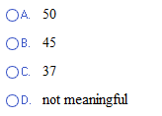
- Predict the value of y for x = 639. Choose the correct answer below
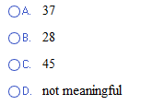
- Predict the value of y for x = 345. Choose the correct answer below
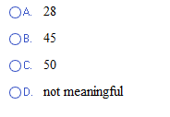
- Predict the value of y for x = 727.Choose the correct answer below
