11
Assume a member is selected at random from the population represented by the graph. Find the probability that the member selected at random is from the shaded area of the graph. Assume the variable x is normally distributed.
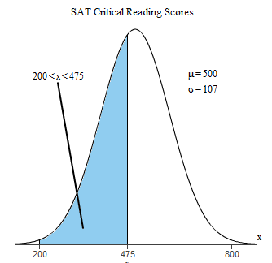

The probability that the member selected at random is from the shaded area of the graph is_________.
(round to four decimal places as needed)

