10
Test the claim below about the mean of the difference of two populations. Use a t-test for dependant, random samples at the given level of significance with the given statistics. Is the test right-tailed, left-tailed, or two-trailed? Assume the populations are normally distributed.
Is the test right-tailed, left-tailed, or two-trailed?
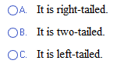
Should the null hypothesis be rejected?
