MINICASE
Ratio Analysis at S&S Air, Inc.
Chris Guthrie was recently hired by S&S Air, Inc., to assist the company with its financial planning and to evaluate the company’s performance. Chris graduated from college five years ago with a finance degree. He has been employed in the finance department of a Fortune 500 company since then.
S&S Air was founded 10 years ago by friends Mark Sexton and Todd Story. The company has manufactured and sold light airplanes over this period, and the company’s products have received high reviews for safety and reliability. The company has a niche market in that it sells primarily to individuals who own and fly their own airplanes. The company has two models; the Birdie, which sells for $53,000, and the Eagle, which sells for $78,000.
Although the company manufactures aircraft, its operations are different from commercial aircraft companies. S&S Air builds aircraft to order. By using prefabricated parts, the company can complete the manufacture of an airplane in only five weeks. The company also receives a deposit on each order, as well as another partial payment before the order is complete. In contrast, a commercial airplane may take one and one-half to two years to manufacture once the order is placed.
Mark and Todd have provided the following financial statements. Chris has gathered the industry ratios for the light airplane manufacturing industry.
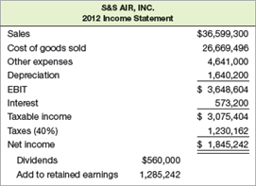
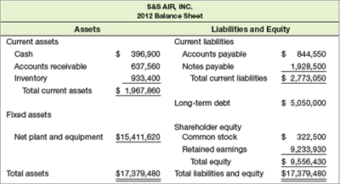
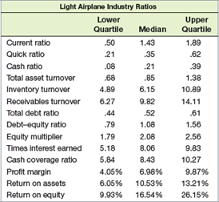
Page 89
You need: (Balance sheet – income statement –ratio analysis)
QUESTIONS
- Using the financial statements provided for S&S Air, calculate each of the ratios listed in the table for the light aircraft industry.
- Mark and Todd agree that a ratio analysis can provide a measure of the company’s performance. They have chosen Boeing as an aspirant company. Would you choose Boeing as an aspirant company? Why or why not? There are other aircraft manufacturers S&S Air could use as aspirant companies. Discuss whether it is appropriate to use any of the following companies: Bombardier, Embraer, Cirrus Design Corporation, and Cessna Aircraft Company.
- Compare the performance of S&S Air to the industry. For each ratio, comment on why it might be viewed as positive or negative relative to the industry. Suppose you create an inventory ratio calculated as inventory divided by current liabilities. How do you think S&S Air’s ratio would compare to the industry average?

