- Write a structural formula for each of the following acids:
  - 4-oxohexanoic acid
  - 2-hydroxy-3-methylhexanoic acid
  - 2-chloropentanedioic acid
  - p-bromophenylacetic acid
- Name each of the following acids.
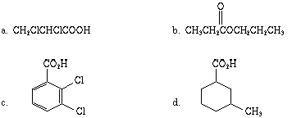
- In each of the following pairs of acids, which would be expected to be stronger, and why?
  - CH₂ClCH₂CO₂H or CH₃CHClCO₂H
  - m-ClC₆H₄CO₂H or p-ClC₆H₄CO₂H
- Give equations for the synthesis of
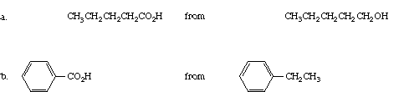
- Write a structure for each of the following compounds:
  - trichloromethyl formate
  - 2-chlorophenyl acetate
  - ethyl benzoate
  - sodium butanoate
- Write an equation for the reaction of phenyl propanoate with
  - hot aqueous sodium hydroxide
  - ammonia (heat)
  - propylmagnesium bromide (two equivalents), then H₃O⁺
  - lithium aluminum hydride (two equivalents), then H₃O⁺
- Write out all the steps in the mechanism for
  - saponification of ethyl benzoate
  - ammonolysis of ethyl benzoate
- Write an equation for
  - esterification of propanoic acid with benzyl alcohol
  - oxidation of toluene with potassium permanganate
  - reduction of propylcyclopentane carboxylate with lithium aluminum hydride
- Write an equation for saponification of glyceryl tripalmitate.
- Write an equation for hydrogenation of glyceryl trioleate.

