1.
ValuMarketers.com has requested that you gather data to better define a conflict that exists between their Sales Executives and Marketing Executives, who are in conflict over the use of ValuMarketers.com’s websites as a source of information for their clients. One generic model of knowledge management is embodied in the diagram below. Using this diagram and your expertise in performance analysis and content analysis, identify four to six (4-6) content sources you will need to review and what questions you will need to have answered through the review of each.
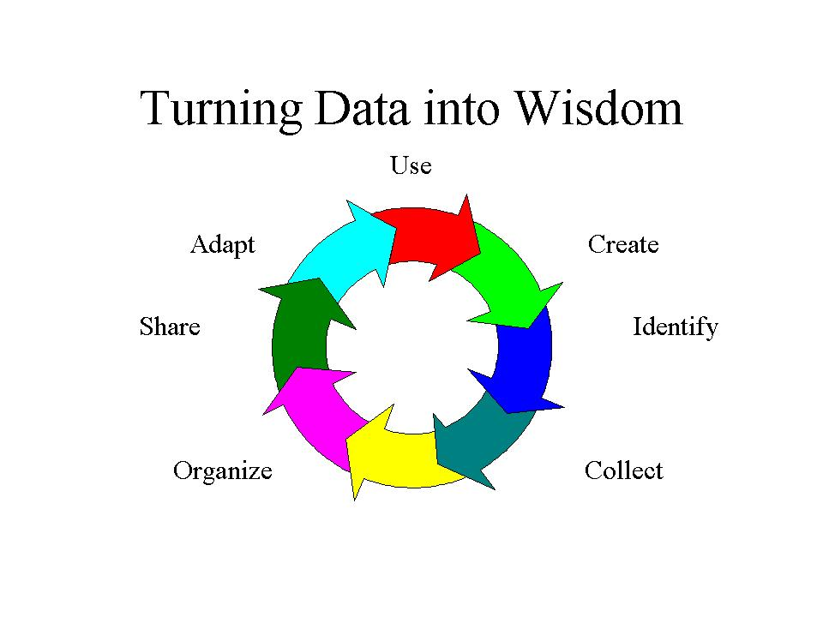
HTML Editor
2.
You have been loaned to a non-profit organization, World-Wide Webmasters’ Webbies (the W4). W4 members tend to be programmers with a smattering of graphic artists and performance practitioners among them. Their goal is rebrand their membership as HPT practitioners. Think about the way that the programmers and graphic artists that you know have learned their craft and think about what you know about professional organizations. What is the most likely cognitive approach of this organization and how will that impact your analysis and reporting?
HTML Editor
3.
You have a completed a quick-and-dirty analysis that agrees with your sponsor on all but one key point. Your sponsor wants you act now – to design and build a specific solution identified by that sponsor’s boss. The data in that one key point shows that the preferred solution will not be accepted by those who must implement it. You have two choices: (a) get agreement for more analysis work before proceeding, or (b) proceed and build in additional analysis along the way hoping that feedback will change either the executive sponsor’s position or the implementers’ position. Choose a position and explain how you will move forward.
HTML Editor
4.
A co-worker has requested that you review her data analysis and resulting report. This person is new to the staff and the performance improvement field but has significant experience as subject matter expert for content creation projects such as learning or documentation of processes. Before reviewing the data and report, identify for yourself a checklist of five or six (5-6) items that you will want to see in the data and in the report. If the data and report do not meet these criteria, you will sit down with this co-worker and the review the checklist. So, for each element, plan a one or two sentence explanation of why it is important in a report that will be seen by executives.
HTML Editor
5.
Xavier and Yvette have been paired up to analyze the needs of ZZZ Sleepers mattress stuffers. ZZZ is experiencing a negative market impact from all the mattresses with air inside. They want to either improve their product or lay off half of their mattress stuffers. Xavier has experience analyzing the needs of project rollouts. Yvette has experience in analyzing the needs of employee development projects. This situation may be neither a rollout nor a development need. What kind of project is this? What strengths will each of these individuals bring to that type of project (besides experience doing other performance analyzes)? Where are they likely to be “in conflict” with each other’s methods? (Note: this question is really about defining the focus of an analysis, the stages of analysis and the probable differences in types of skills that someone specializing in one situation will have.)

