4. Break-Even Analysis
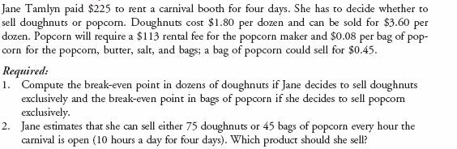

5. Ratio Analysis
Required: Calculate the requested ratios using the financials below:
Income Statement (figures in millions of dollars)
Net sales | 16,725
Cost of goods sold | 5,372
Other expenses | 5,105
Depreciation | 1,823
Earnings before interest and taxes (EBIT) | 4,425
Interest expense | 750
Income before tax | 3,675
Taxes | 1,323
Net Income | 2,352
Dividends | 1,250

Balance Sheet (figures in millions of dollars)
Assets | End of Year |  | Start of Year
Cash and marketable securities | 214 |  | 108
Receivables | 2,507 |  | 2,490
Inventories | 312 |  | 325
Other Current Assets | 992 |  | 500
Total Current Assets | 4,025 |  | 3,423
Net, Property, Plant & Equipment | 20,098 |  | 21,415
Other long-term assets | 4,341 |  | 4,200
Total Assets | 28,464 |  | 29,038
Liabilities & Shareholders' Equity
Payables | 2,709 |  | 2,500
Short-term debt | 1,569 |  | 1,570
Other current liabilities | 1,016 |  | 800
Total Current Liabilities | 5,294 |  | 4,870
Long-term debt and leases | 7,018 |  | 9,200
Other long-term liabilities | 6,428 |  | 7,468
Shareholder's Equity | 9,724 |  | 7,500
Total Liabilities & Shareholders' Equity | 28,464 |  | 29,038

- Operating Profit Margin
- Total Debt Ratio
- Long-Term Debt Ratio
- Return On Assets
- Inventory Turnover

