Chapter 9 review
- Name each of the following compounds.
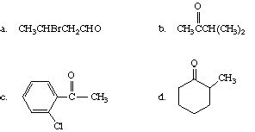
- Write a structural formula for each of the following compounds.
  - benzyl methyl ketone
  - 2-pentenal
  - 2-chloro-3-hexanone
  - 2,3-dimethylpentanal
- Write an equation for the synthesis of 2-hexanone by
  - oxidation of an alcohol
  - hydration of an alkyne
- Write an equation for the reaction of propanal with each of the following reagents, and name the organic product.
  - cyanide ion
  - sodium borohydride
  - phenylmagnesium bromide, then H₃O⁺
- Using a Grignard reagent and the appropriate aldehyde or ketone, show how each of the following can be prepared.
  - 2-phenyl-2-butanol
  - 2-hexanol
  - 1-pentene-3-ol
- Complete the equation for the reaction of
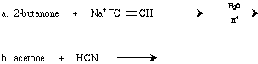
- Give the structure of each product.
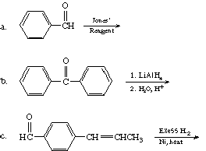
- Write out the steps for the aldol condensation reaction between the enolate anion of propanal with pentanal.

