Chapter 8 review
- Write a structural formula for each of the following compounds:
  - isopropyl methyl ether
  - trans-2-pentene oxide
  - 3-ethoxyhexane
  - ethylene glycol dipropyl ether
- Name each of the following compounds.
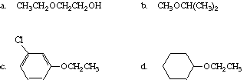
- Ethers and alcohols can be isomeric. Write the structures, and give the names for all possible isomers with the molecular formula C₄H₁₀O.
- Write equations for the reaction of each of the following with (1) Mg in ether followed by (2) addition of D₂O to the resulting solution.
  - (CH₃)₂CH CH₂Br
  - CH₃CH₂OCH₂CBr(CH₃)₂
- Write equations for the best method to prepare each of the following ethers:
  - CH₃CH₂CH₂OCH₂CH₃
  - (CH₃)₂CHCH₂OCH₂CH(CH₃)₂
- Write an equation for each of the following reactions. If no reaction occurs, say so.
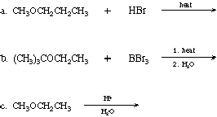
- Write equations to show how 1-pentanol can be synthesized from bromopropane and ethylene oxide, using a Grignard reagent.

