12
Use technology to find the regression equation for the data shown in the table. Then answer the following.
- What is the standard error estimate?
- What is the coefficient of determination?
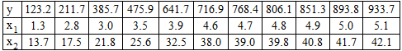
What is the regression equation?
Y = _______ + (_______)x₁ + (_______)x₂
(round three decimal places as needed)
- The standard error is ________
(round three decimal places as needed)
- The coefficient of determination is ________
(round three decimal places as needed)

