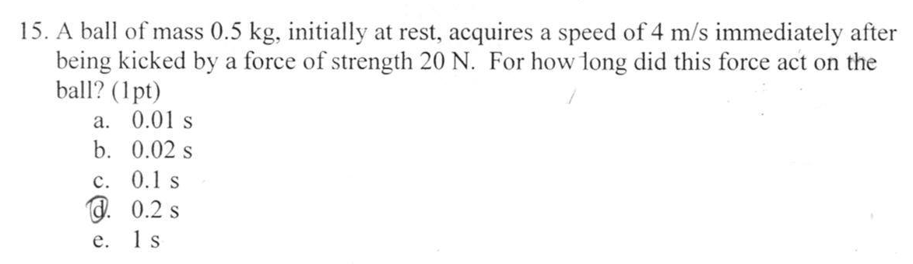
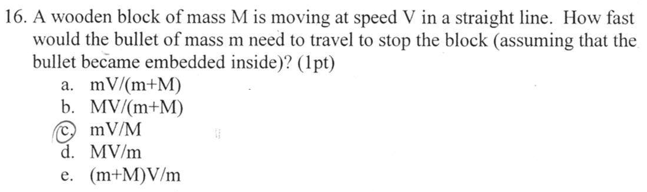
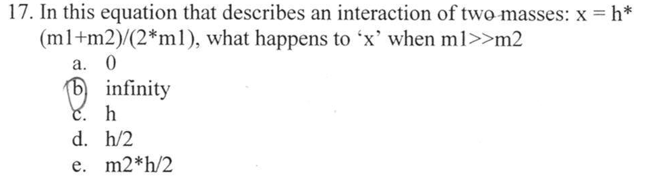
Please ignore the circled answers. They are wrong answers.

