Comprehensive Problem: Chapters 3 to 7

Raymond Company has the following opening account balances in its general and subsidiary ledgers on January 1 and uses the periodic inventory system. All accounts have normal debit and credit balances.
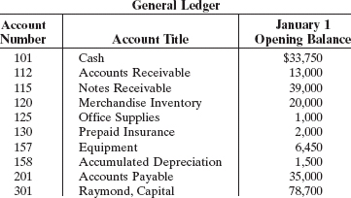

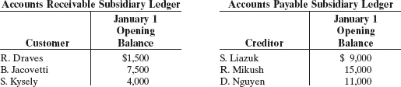

Jan. 3 | Sell merchandise on credit to B. Soto $3,100, invoice no. 510, and J. Ebel $1,800, invoice no. 511.
5 | Purchase merchandise from S. Welz $3,000 and D. Laux $2,700.
7 | Receive checks for $4,000 from S. Kysely and $2,000 from B. Jacovetti.
8 | Pay freight on merchandise purchased $180.
9 | Send checks to S. Liazuk for $9,000 and D. Nguyen for $11,000.
9 | Issue credit memo for $300 to J. Ebel for merchandise returned.
10 | Summary cash sales total $15,500.
11 | Sell merchandise on credit to R. Draves for $1,900, invoice no. 512, and to S. Kysely $900, invoice no. 513.  Post all entries to the subsidiary ledgers.
12 | Pay rent of $1,000 for January.
13 | Receive payment in full from B. Soto and J. Ebel.
15 | Withdraw $800 cash by I. Raymond for personal use.
16 | Purchase merchandise from D. Nguyen for $15,000, from S. Liazuk for $13,900, and from S. Welz for $1,500.
17 | Pay $400 cash for office supplies.
18 | Return $200 of merchandise to S. Liazuk and receive credit.
20 | Summary cash sales total $17,500.
21 | Issue $15,000 note to R. Mikush in payment of balance due.
21 | Receive payment in full from S. Kysely.  Post all entries to the subsidiary ledgers.
22 | Sell merchandise on credit to B. Soto for $1,700, invoice no. 514, and to R. Draves for $800, invoice no. 515.
23 | Send checks to D. Nguyen and S. Liazuk in full payment.
25 | Sell merchandise on credit to B. Jacovetti for $3,500, invoice no. 516, and to J. Ebel for $6,100, invoice no. 517.
27 | Purchase merchandise from D. Nguyen for $14,500, from D. Laux for $1,200, and from S. Welz for $2,800.
28 | Pay $200 cash for office supplies.
31 | Summary cash sales total $19,920.
31 | Pay sales salaries of $4,300 and office salaries of $2,600.

Instructions
- Record the January transactions in the appropriate journal—sales, purchases, cash receipts, cash payments, and general.
- Post the journals to the general and subsidiary ledgers. New accounts should be added and numbered in an orderly fashion as needed.
- Prepare a trial balance at January 31, 2005, using a work sheet. Complete the work sheet using the following additional information.
1. | Office supplies at January 31 total $700.
2. | Insurance coverage expires on October 31, 2005.
3. | Annual depreciation on the equipment is $1,500.
4. | Interest of $30 has accrued on the note payable.
5. | Merchandise inventory at January 31 is $16,000.
- Prepare a multiple-step income statement and a statement of owner's equity for January and a classified balance sheet at the end of January.
- Prepare and post the adjusting and closing entries.
- Prepare a post-closing trial balance, and determine whether the subsidiary ledgers agree with the control accounts in the general ledger.

