The director of an investing group believes that the sales generated by a broker is related to the number of new clients a broker brings to the firm. The director believes that a linear regression model would help in the forecasting of expected sales from the brokers. To build the model the director takes a random sample of 12 brokers and gets the following results:
Broker | No. of Clients | Sales ($000)
1 | 27 | 52
2 | 11 | 37
3 | 42 | 64
4 | 33 | 55
5 | 15 | 29
6 | 15 | 34
7 | 25 | 58
8 | 36 | 59
9 | 28 | 44
10 | 30 | 48
11 | 17 | 31
12 | 22 | 38

Excel Output

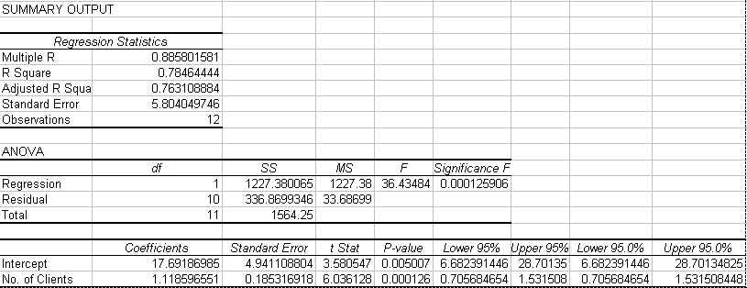

- What is the independent variable and the dependent variable?
- What is the forecasting equation derived from the Excel data?
- What is the null and alternative hypotheses being tested for the independent variable?
- $ρ$Using the t statistic method can you reject the null hypothesis at the 5% level of significance?
- What is the estimated sales revenue of a broker who recruits 40 new clients?
- What percent of the estimated sales revenue can be explained by the number of new clients a broker brings to the firm?

