1) A bead is placed at each of the six vertices of a regular hexagon, and each bead is to be painted either red or blue, how many distinguishable patterns are there under equivalence relative to the group of rotations of the hexagon?
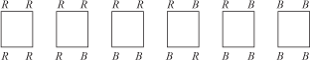
2) Repeat Problem 8 with a regular hexagon in place of a regular pentagon.
3) In how many distinguishable ways can the four faces of a regular tetrahedron be painted with four different colors if each face is to be a different color and two ways are considered indistinguishable if one can be obtained from the other by rotation of the tetrahedron? (The group of rotations in this case has order 12. In addition to the identity, there are eight 120° rotations around lines such as ae in the following figure, and three 180° rotations around lines such as fg.)
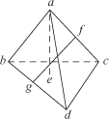
Use Burnside’s Counting Theorem to compute the number of orbits for the group 〈(1 2 3 4)(5 6)〉 acting on {1, 2, 3, 4, 5, 6}. What are the orbits?

