1. A spherical balloon is inflated with gas at the rate of 800 cubic centimeters per minute. How fast is the radius of the balloon increasing at the instant the radius is (a) 30 centimeters and (b) 60 centimeters?

12. An air traffic controller spots two planes at the same altitude converging on a point as they fly at right angles to each other (see figure). One plane is 225 mile from the point moving at 450 miles per hour. The other plane is 300 miles from the point moving at 600 miles per hour.

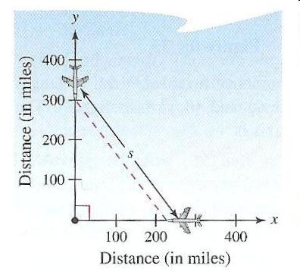

(a) At what rate is the distance between the planes decreasing?

(b) How much time does the air traffic controller have to get one of the planes on a different flight path?

