FROM: George Washburn
SUBJECT: Annual Productivity Plan
The Plasit-brack product line is an important part of our business and with your qualifications, I am looking for some good things to happen with these products.
I am announcing the annual productivity plan and goal, which is for EMC to improve productivity this year by 5% overall. I am asking each manager to develop a productivity plan for their areas. This plan is to identify areas of productivity, the productivity measurements, and provide a plan for how the productivity will be accomplished.
I want you to consider using this multi-factor productivity measure: (Total Production of Plasti-bracks) / (Total Paid Labor Hours). Using the most recent data available, this Productivity Measure is 391.25 pcs produced per paid people hours, for Plasti-Brack. You can review the detailed data to see how I determined this measurement. A 5% increase translates to 410.81 pcs/pd ppl hr.
Given this overall productivity measure and the 5% goal, you should consider your next steps. First, do an assessment of the current situation. Then determine other subordinate productivity indices or factors that will be measured in your area of responsibility. What are the main issues and concerns about improving productivity this year? What are some of the possible processes that should be considered for process re-engineering or “lean” analysis? What improvements are you planning on making, and how will these make the 5% productivity goal?
Please do this analysis for your area. You should consult with the production managers as necessary. I want a report that provides an assessment of productivity measures and process improvement issues for the Plasti-brack product line and related production processes.
Reference Material For project:

The Excellent Manufacturing Company
Corporate information
Established: February, 1995, Columbus, Ohio
- President/CEO: Jack Walker (original founder)
- Division of National Building Supply
- Subsidiary of RexMag - an international conglomerate of diversified products
EMC ORG CHART
- 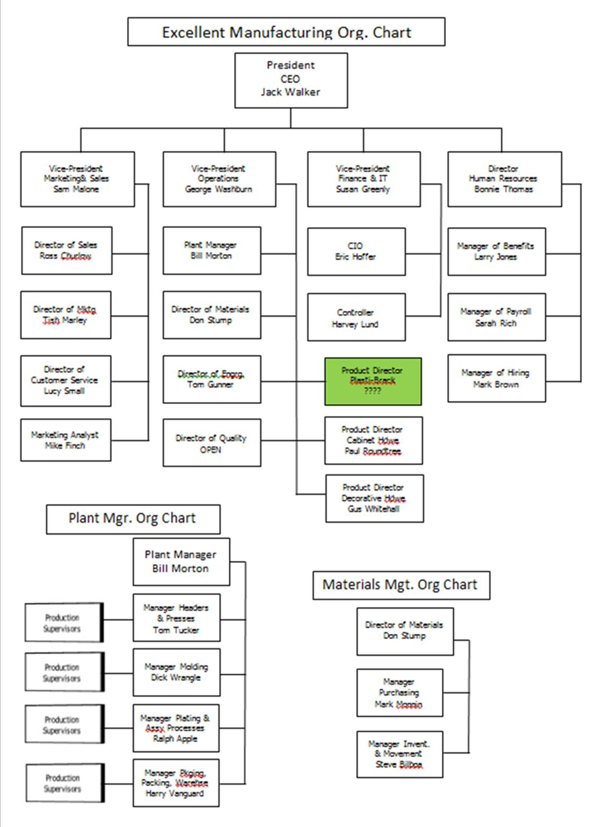

Size and customer info:
- Gross Sales: Approximately $13,000,000
- Total Employees: Approx. 105
- Customers: National and regional home improvement centers and building supply outlets
- The following is the Income Statement from the year just completed.
 | Gross Income |  | COGS |  | Gross Margin
PRODUCT LINE | (000s) |  | (000s) |  | (000s)
Fasteners | $ 1,010 | 7.3% | $ 646 | 4.7% | $ 364 | 2.6%
Cabinet Hardware | $ 3,243 | 23.5% | $ 1,783 | 12.9% | $ 1,460 | 10.6%
Construction Hardware | $ 4,165 | 30.2% | $ 1,874 | 13.6% | $ 2,291 | 16.6%
Decorative Hardware | $ 5,388 | 39.0% | $ 2,586 | 18.7% | $ 2,802 | 20.3%
TOTALS | $ 13,806 | 100.0% | $ 6,889 | 49.9% | $ 6,917 | 50.1%
OPERATING EXPENSES
Marketing and Advertising |  |  | $ 850 | 6.2%
Commissions, Wages & Salaries |  |  | $ 1,750 | 12.7%
Benefits |  |  | $ 770 | 5.6%
Office Expenses |  |  | $ 175 | 1.3%
Depreciation |  |  | $ 734 | 5.3%
Insurance |  |  | $ 943 | 6.8%
Fixed Energy & Utility Expenses |  |  | $ 268 | 1.9%
Miscellaneous |  |  | $ 132 | 1.0%
TOTAL OPERATING EXPENSES |  |  |  |  | $ 5,622 | 40.7%
Net Income Before Taxes |  |  |  |  | $ 1,295 | 9.4%
- The following is the Statement of Inventories (from the Balance Sheet) for the year just ending:
 | Beginning | Ending
Inventories | (000s) | (000s)
Raw | $ 205 | $ 167
Purch Parts | $ 148 | $ 151
WIP | $ 389 | $ 322
Fin. Goods | $ 242 | $ 243
TOTAL INVEN | $ 984 | $ 883
- NOTES ON INVENTORIES AND MATERIAL MOVEMENT
- EMC does not account for inventories on a product line basis. But generally, each product line uses its proportionate share of the inventories based on costs.
- Plastic resin is moved to the molding macnines where it is dumped into feeding hoppers for each machine. As the hopper empties, additional resin is dumped in.
- The plastic parts come out of the molding machines and are trimmed where they are collected in 10 cu. ft. tubs. These tubs are moved to the Plasti-Brack assembly area.
- The plain brackets are stamped out by the progressive dies in the Plasti-Brack press machine group. They are also collected in 10 cu. ft. tubs and then moved to the Plasti-Brack assembly area.
- In the assembly process, the operator will do a quick visual check of the plastic insert and the plain bracket before assembly. Bad parts are discarded into tubs. The plastic is recycled via a regrind process. The steel parts cannot be used again and sold for scrap with the rest of the scrap metal.
- The assembled Plasti-Brack items are collected in 10 cu. ft. tubs and are eventually moved to the Bulk Pack area. Once they are packed, they move into the Finished Goods Warehouse where they wait to be picked and packed in large shipping containers to the customers.
Products: Construction and building items:
- FASTENERS
  - screws, bolts, nails
- CONSTRUCTION
  - Flanges
  - Brackets – Plasti-Brack (see below for more details)
- CABINET HARDWARE
  - Hinges
  - Knobs
  - Pulls
- DECORATIVE HARDWARE
  - Towel Bars
  - Towel Rings
  - Soap Dishes
  - Switch Plates
  - Outlet Plates

Manufacturing processes: EMC Plant Layout
Denotes processes for Plasti-Brack products
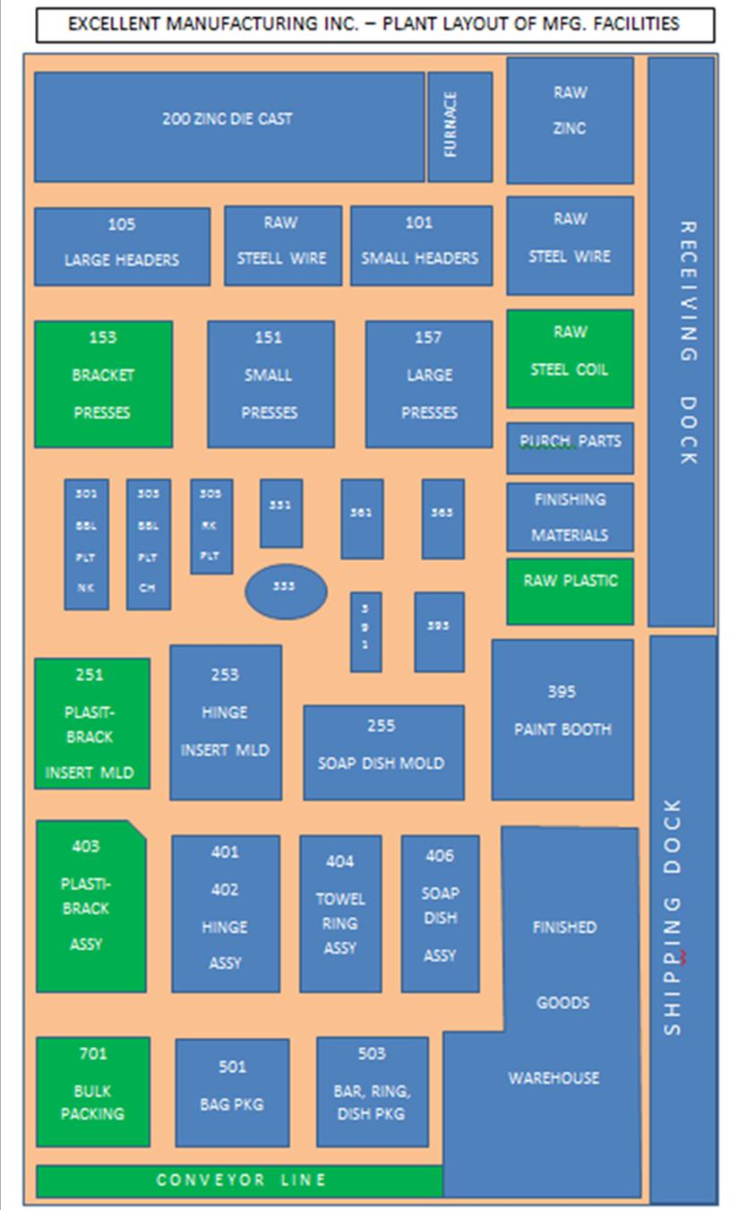

(EMC Capacity)
- 100 Heading
  - 101 small headers
  - 105 large headers
- 150 Blanking & Stamping
WANT TO LEARN MORE ABOUT HOW VARIOUS MANUFACTURING PROCESSES WORK?
Wikipedia has a resource that describes different manufacturing processes.
Standford Univ. has a resource with VIDEOS. This is really good! To see different processes, click on the processes tab at the left of the window. There are also videos on how specific products are made. Some of these are very interesting.
  - 151 small presses
  - 153 Bracket presses
  - 157 large presses
- 200 Zinc Die Cast Molding & Trimming
  - 201 small zinc molders
  - 203 trim, small
  - 206 large zinc molders
  - 208 trim,large
- 250 Plastic Injection Molding
  - 251 Plasti-brack insert molding
  - 253 Hinge insert molding
  - 255 Soap dish molding
- 300 Plating
  - 301 Barrel Plating – nickel
  - 303 Barrel Plating – chromium
  - 305 Rack Plating
- 330 Brushing
  - 331 Straight line brushing
  - 333 Circular line brushing
- 360 Lacquer
  - 361 Spray lacquer line
  - 363 Brush lacquer line
- 390 Painting
  - 391 Paint line 1
  - 393 Paint line 2
  - 395 Paint booth
- 400 Assembly
  - 401 Hinge Assembly
  - 402 Hinge Assembly - auto
  - 403 Plasti-brack Assembly
  - 404 Towel Ring Assembly
  - 406 Soap Dish Assembly
- 500 Packaging
  - 501 Bag Packaging
  - 503 Bar, Ring, Dish Packaging
- 700 Packing
  - 701 Bulk Packing

The Plasti-Brack Product Line: combination metal / plastic supports
- Six products, different angles. F90, F100, F120A, F120B, F130, F135
- Novel item patented by Excellent
- Unique design includes a simulated wood finish and color in the plastic insert
- Allows it to be used both for internal and external construction
- Very popular in deck, fence, and shed construction, as well as in home construction.

EMC - Capacity Issues: Capacity & Forecasting
Overall, the current capacity utilization at EMC is 92%. This ranges from about 75% in the blanking machine groups to about 93% in the plastic molding groups. Assembly, packaging and packing are near 80%, while the finishing processes are around 88%.
Currently, all departments are running just one 40 hour shift. Occasionally, some departments will add some overtime on a weekly basis as needed to stay up with orders. Bill Morton, the Plant Manager, prefers to run with one shift. His opinion is that adding a second shift is not as efficient since it adds more fixed costs in enegy consumption, just to have the lights on. Additional shifts require additional employees. It costs money to hire and train them. Plus employees earn a 15% shift premium. Morton would rather pay the time & a half for the additional hours over 40. And Morton would prefere that his capacity utilization be around 85%. He is a little nervous with the 92% level.
Mike Finch does the forecasting for EMC, both short-term and long-term. His short-term forecast is broken down by product line. His short-term forecast for Plasti-Brack products indicates that there will be a small increase this year of 7% to 10%.
Finch's long term forecast is across the board for all of EMC and its various products. His results indicate that there will be a 12.5% annual compound growth over the next five years. This equates to an 80% increase over the current demand in the fifth year.
SAMPLE DRAWING & SAMPLE PROCESS FLOW CHART
Figure 1 shows a sample drawing of the F90. The P90 is the plastic insert, the S90 is the steel bracket and the F90 is the assembly of the P90 and S90. Figure 2 shows the process flow chart for the B-F90, which is the bulk packed F90.
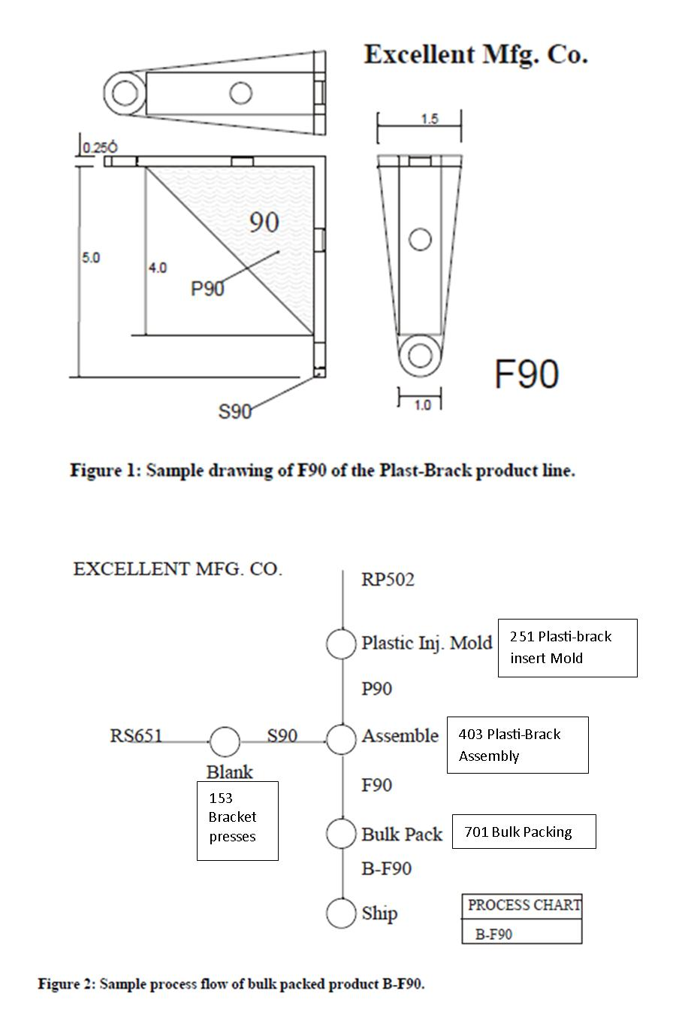

Plasti-Brack processes and descriptions
(Productivity Calculations)
Mach hrs: hours for all machines in a production area
PPM: People per machine, e.g. how many people to run a machine, e.g. 0.5 means that one person runs two machines
People hrs: hours for all people in a production area
Production: Hours producing peices
Setup: Hours changing over or setting up dies
Pd Non-Prod: Hourse paid doing non-production work (not producing pcs), e.g. maintenance, clean-up, etc.
 |  | Production | Setup | Pd non-Prod | Total Mach Hrs | Total Ppl Hrs
Blanking | Mach hrs | 3337 | 467 | 223 | 4027
 | ...PPM | 0.5 | 1 | 1
 | People hrs | 1668.5 | 467 | 223 |  | 2,358.50
Molding | Mach hrs | 4195 | 712 | 250 | 5157
 | ...PPM | 0.25 | 1 | 1
 | People hrs | 1048.75 | 712 | 250 |  | 2,010.75
Assembly | Mach hrs | 33372 | 0 | 1050 | 34422
 | ...PPM | 1 | 1 | 1
 | People hrs | 33372 | 0 | 1050 |  | 34,422.00
Packing | Mach hrs | 667 | 0 | 50 | 717
 | ...PPM | 3 | 3 | 3
 | People hrs | 2001 | 0 | 150 |  | 2,151.00
Total hrs |  |  |  |  | 44,323.00 | 40,942.25
Total Plasti-Brack Pcs |  |  |  |  |  | 16,018,752
Total Ppl Hours |  |  |  |  |  | 40,942.25
Productivity Measure |  | Pcs produced/Ppl Hr |  |  |  | 391.25
Productivity Goal |  |  |  |  | 105% | 410.81

Info about Quality
EMC has not had a quality manager or quality department. One has just been hired to develop a Quality Department.
The process operators have taken quality seriously on their own. They make sure that the tools and work stations are setup correctly. They also check the quality of parts periodically as they are produced. But they do not follow any specific quality methods or techniques. This approach to quality is the same in all of the various production departments.
The majority of the production quality issues seems to be scrapping bad plastic inserts during the assembly process. A lot of 10 cu. ft. tubs accumulate in Plasti-Brack assembly. But no one seems to be concerned since these parts are very low cost and the plastic scrap is re-processed. Plastic scrap goes to a re-grind operation, where it is ground up into fine pieces. It is then added to the virgin raw material in a 1 to 9 ratio in the Plastic Injection Molding Department.
Overall Excellent Manufacturing does not have many big issues from customer complaints. There are occasional returns of various products, mostly because of plating and finishing problems. In terms of Plasti-Brack products, complaints are about the plastic insert falling out and about sharp edges on the brackets. Last year there were 56 complaints complaints. They seem to be on the rise as there are 49 complaints this year during the first four months.

Machine group 153 Bracket presses.
- Two 400-ton presses
- machine speed is 40 strokes per minute, or 2400 pieces per hour
- Progressive die process, so that one bracket part is produced per stroke
- Six progressive dies, one for each part.
- setup (die change over), approx. 3.5 hours
Machine group 251 Plasti-Brack insert Mold
- Four 250-ton plastic injection molding machines
- There are six dies, one for each plastic insert
- Cavities per die
  - P90 die 6 cavities
  - P100 die 5 cavities
  - P120A die 8 cavities
  - P120B die 4 cavities
  - P130 die 7 cavities
  - P135 die 8 cavities
- Machine speeds: Plastic injection molding speed is from 18 - 22 seconds/shot
  - see table below for Pieces/hr.
- Setup (die change over), approx. 4 hours
Machine group 403 Plasti-Brack Assembly
- Seven assembly stations – tables for operators
- One operator per station
- The rate for the manual assembly operation is 8 pieces per minute or 480 pieces per hour
- The assembly process consists of:
- grasp a plastic insert (P90)
- visually inspect insert
  - if defective, toss into scrap bin and go to step 1, OR
  - keep for next step
- grasp a bracket (S90)
- move the insert to the assembly point
- push insert into place
- check assembly
  - if insert will not assemble properly, toss into scrap bin, go to steps 1, 2, 4, & 5, OR
  - if insert does assemble properly, then
- drop assembly into 10 cu. ft. Tub at the side of the table.
- Operators are trained to also do Hinge Assembly, Towel Bar, Towel Ring and Soap Dish assembly
Machine group 701 Bulk Packing
- Three operators work together on this line
- Plasti-bracks move here from 403 Plasti-Brack Assembly
- Each Plasti-brack is dumped in bulk into a cardboard box
- Each box holds 100 of one of the items.
- Measuring the number in the box is accomplished by “weigh counting”
- A lid assembled to the full box
- A label is attached to the box
- The closed container is banded by a banding machine on the conveyer line
- The completed container is sent to the warehouse
- The speed of this line is 4 containers per minute (400 pieces/min.), or 240 containers/hour (24000 pieces/hr.)
- NOTE: Hinges are also “bare” bulk packed for cabinet makers. Otherwise hinges are bag packed first, then bulk packed to be sent to home supply stores.
MACH. GRP. 251
PIECES PER HOUR
 | M101 | M102 | M103 | M104
P135 | 1309.1 | 1600.0 | 1440.0 | 1440.0
P120A | 1309.1 | 1600.0 | 1440.0 | 1440.0
P130 | 0.0 | 1260.0 | 1145.5 | 1145.5
P100 | 818.2 | 0.0 | 900.0 | 900.0
P90 | 1080.0 | 1350.0 | 1200.0 | 1200.0
P120B | 640.0 | 800.0 | 720.0 | 720.0
MATERIAL HANDLING DATA:
PIECES PER 10 CU. FT. TUB
P135 | 1937 |  | F135 | 1191
P120A | 1581 |  | F120A | 1030
P130 | 1678 |  | F130 | 1075
P100 | 1305 |  | F100 | 891
P90 | 1369 |  | F90 | 924
P120B | 816 |  | F120B | 609

