I. Effective Implementation of Change
The speed of economic, global, and technological development makes change an inevitable process in the workplace. The rate at which change takes place in organizations today compared to even just ten years ago is astonishing. Many individuals will attest that the only thing constant in their workplace is continual change. Individuals who cannot adjust quickly in this changing environment frequently are afraid and uncomfortable. Getting all employees to buy into the change is probably the major task that management faces when trying to implement any type of change, small or big.
Organizations use planned change to solve problems resulting from external and internal issues. The ultimate goal is to improve performance and overall organizational effectiveness. Change is usually initiated and implemented by managers. Concepts of change focus on how change can be implemented in organizations; frequently referred to as “theories of changing.” It is imperative for individuals planning the change process to identify and understand the activities that need to take place to initiate and carry out successful organizational change.
For decades individuals have studied the change process. One of the earliest models of planned change was designed by Kurt Lewin. The scientific study of Kurt Lewin began after World War II. He identified a particular set of behaviors that at any moment in time is the result of two groups of forces. One group strives to maintain the status quo and the other group pushes for change. Therein lies the problem; two groups of individuals diametrically opposed to each other. The success or failure of a planned change process is significantly affected by management’s ability to engage the staff and demonstrate why the maintaining the status quo will not be productive. Furthermore, management needs to clearly describe a compelling future and outline how the organization will benefit from the change.
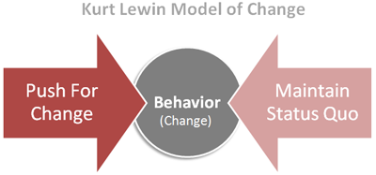

II. Effective Approach to Organizational Change

The Change Agent Role
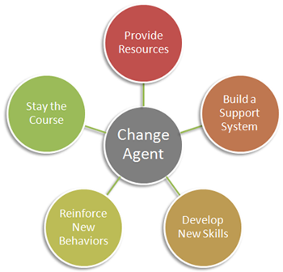
Management needs to take on the role of the change agent. Change agents are the individuals who become responsible for changing the existing pattern of behavior of another person or group of individuals. A good change agent needs to skillfully do the following:

- Provide resources for change
Implementing change in an organization usually requires additional financial and human resources. If these extra resources are not planned for and provided, meaningful change will not occur.
- Build a support system to handle tension
Change causes extreme tension. Throughout the process, individuals need a mechanism to vent and deal with the stress that is caused by change.
- Develop new skills
Many times change requires employees to take on a different role. Change agents need to be certain that the workforce is properly prepared to take on this new role.
- Reinforce new behaviors
Employees generally do things that bring them some type of reward. It may be monetary or non-monetary. Managers need to implement a reward system that encourages new behavior.
- Stay the course
Change agents need to be able to stay on target because change does not happen overnight. It is also important to fully implement the change process and then hold the gain.
Employee participation is vital during a planned change process. What leaders need to understand is that they cannot just tell employees there is a need for change. They need to convince employees that the change is necessary and demonstrate how the change will bring the organization to a higher level of performance and thus profit. A perfect example of organizational change that was necessary to bolster growth and remain competitive was when IBM revitalized its market strategy and product line architecture during the 1990s. IBM learned that the need for strategic and product line renewal was imperative when net earnings of about $6 billion one year later was reduced to a net loss and the loss continued to grow significantly over the next 2-3 years. Management had to quickly turn the organization around and closely look at user needs/frustrations and the need for new product design in hardware and software. This endeavor required unprecedented employee participation at all levels.
Read The Role of a Change Master
What roles have you participated in? Which roles do you play now?

III. Types of Change
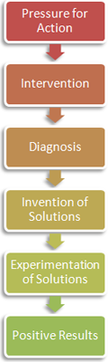
Planned Change
Strategic and comprehensive changes typically follow a top-down process which includes the following steps:
Step 1: Pressure on top management from external or internal forces arouses the need to take action.
Step 2: Intervention at the top causes the need for reorientation to internal problems.
Step 3: A diagnosis of problem areas takes place and specific problems are identified.
Step 4: New solutions are invented and management makes a commitment to a new course of action.
Step 5: New solutions are experimented and a search for positive results takes place.
Step 6: The positive results create acceptance for new practices.
Bottom-up change can also take place. The efforts of middle managers and other employees throughout the organization can initiate change. This type of change can be very innovative and usually has impact on the requirements of work. When upper management supports bottom-up change employees become empowered and participate at a higher level in the elements of the change process.
Unplanned Change
Not all change is a result of management’s direction. Unplanned change can happen at random and may be very disruptive to the work environment. Organizations are frequently affected by unplanned change as a result of a union strike, an interpersonal conflict or accident on the job. An even more pressing issue is the change in consumer needs and wants which definitely can affect the bottom-line. Therefore, it is imperative that management act immediately once an unplanned change is identified so that the negative consequences are limited.
Unplanned change takes place in all industries. One of particular interest is what has been happening in the automobile industry. With the rising cost of fuel, consumers want to purchase more fuel efficient automobiles. However, in America, we are still in love with our automobiles. We want to feel good about what we are driving. A prime example of an organization that had to adjust is Ford Motor Company. What they found out is that “they could make money on small cars” (Korzeniewski, 2010). They quickly developed a plan to increase small car profits and bolster vehicle connectivity. As a result, Ford expects to reap double-digit percentage profit improvement with their new models that are fuel efficient. More importantly, the attractive designs are expected to significantly increase consumer interest.

Check Your Understanding

References:
Palmer, I., Dunford, R., & Akin, G. (2009) Managing organizational change: A multiple perspectives approach. (2nd ed.). Boston, MA: McGraw Hill.
Korzeniewski, J. (2010). Ford: We can make money on small cars! Retrieved from http://www.autoblog.com/2008/08/13/ford-we-can-make-money-on-small-cars/
Spector, B. (2010). Implementing organizational change: Theory and practice (2nd ed.). Boston, MA: Prentice Hall.

