You are working in a laboratory investigating the effects of new chemicals called X and Y that kill cells. To test whether X and Y cause necrosis or apoptosis, you briefly treat cultured cells with each chemical and perform several assays.
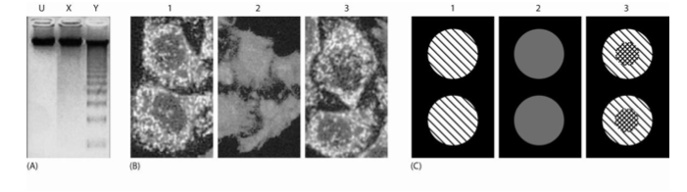
A. First, you examine the chromosomal DNA. You isolate DNA from cells, label 5’ ends with radioactive ATP by using polynucleotide kinase, run the DNA on a gel, and detect radiolabeled fragments. Your results are shown in Figure A . The lane from the untreated control cells is labeled U. Does X cause apoptosis? What about Y? Explain the origin of the ladder in the Y lane.
B. Second, you examine the subcellular localization of cytochrome c using immunofluorescence microscopy. Unfortunately, during sample preparation you mixed up the samples. Assign a likely identity (U, X, or Y) to the samples labeled 1, 2, and 3 in Figure B.
C. Third, without making the cells permeable in any way, you stain them with Annexin V linked to a green fluorophore, which binds phosphatidylserine, and propidium iodide, which fluoresces red when it binds DNA. Neither of these compounds can travel across intact plasma membranes. Again during sample preparation you mixed up the samples. Assign a likely identity to the samples in Figure C. Annexin V staining is shown as \\ hatching, propidium iodide staining is shown as // hatching, and staining with both in the same region appears as crosshatching.

