Sprint Shoes, Inc. had a beginning inventory of 9,000 units on January 1, 2007. The costs associated with the inventory were:
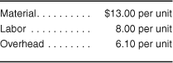
During 2007, the firm produced 42,500 units with the following costs:
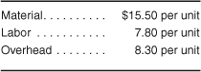
Sales for the year were 47,250 units at $39.60 each. Sprint Shoes uses LIFO accounting. What was the gross profit? What was the value of ending inventory?

