Which of the following substances can exist in an optically active form?
  - 1,3-dibromopropane
  - ethyl cyclohexane
  - 3-ethylpentane

Locate with an asterisk the chiral centers in the following structures.
Tell whether the following structures are identical or enantiomers.
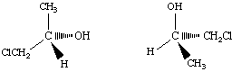
Draw a structural formula for an optically active compound with a molecular formula:
  - C₄H₉Br
  - C₅H₉Br
Draw the formula of an unsaturated chloride, C₄H₇Cl, that can show
  - no cis-trans isomerism but optical activity
  - cis-trans isomerism but no optical activity
  - neither cis-trans isomerism nor optical activity
Place the members of the following groups in order of decreasing priority according to the R-S convention.
a. | H | Cl | Br | CH₃
b. | OH | CH₃ | CH₂Cl | CH₃CH₂
c. | CH₃ | CH₂CH₃ | Cl | C₆H₅
Assume that the four groups in each part of problem 6 are attached to one carbon atom. Draw a three-dimensional formula for the R configuration of the molecule.

Tell whether the chiral centers marked with an asterisk in the following structures have the R or the S configuration:
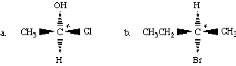
Name the following compounds, using the E-Z notation.
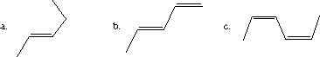

How many stereoisomers are possible for each of the following structures? Draw them, and name each by the R-S and E-Z conventions.
  - 4-methyl-2,5-heptadiene
  - 1,2,5-trichloro-3-hexene
What is the configuration, R or S, at each chiral center in
Draw the two possible diastereomeric products in this reaction, and assign R or S designations to all the chiral centers. (Use Fischer projections to show products.)
