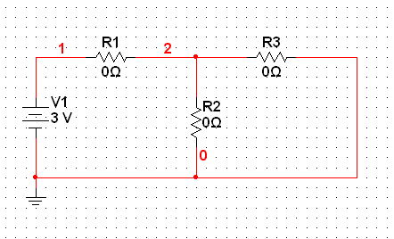
Figure 1
- Given that the current flowing through R1 is 2A and the current flowing through R2 is 4A, determine the current flowing through R3.
- Based upon the given and calculated values, determine the following:
  - R1
  - R2
  - R3
  - PR3 (power dissipated by R3)

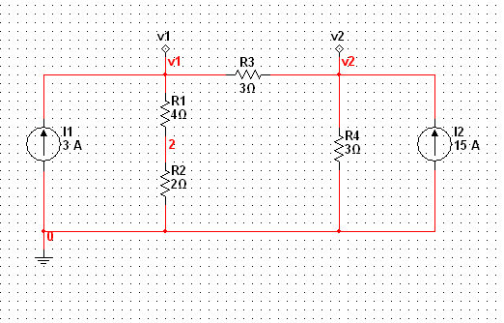
Figure 2
- Determine the current flowing through R3.
- Calculate v1 – v2

