The following figure shows the devastating effect the opening of a new discount department store had on an established department store in a small town. The revenue of the discount store at time t (in months) is given by f(t) million dollars, whereas the revenue of the established department store at time t is given by g(t) million dollars. Answer the following questions by giving the value of t at which the specified event took place.
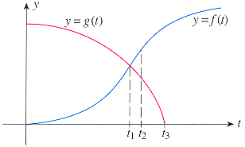
(a) The revenue of the established department store is decreasing at the slowest rate.
t =

According to a study conducted in 2003, the total number of U.S. jobs that are projected to leave the country by year t, where t = 0 corresponds to 2000, is represented by the following function where N(t) is measured in millions.
N(t) = 0.0018425(t + 8)^{5.5} (0 t 15)
How fast was the number of U.S. jobs that are outsourced changing in 2004? How fast will the number of U.S. jobs that are outsourced be changing at the beginning of 2012 (t = 12)? (Round your answers to the nearest whole number.)
2004 | jobs/year
2012 | jobs/year

In the pair of supply and demand equations below, x represents the quantity demanded in units of a thousand and p the unit price in dollars.
p = 47 - 2x² and p = x² + 9x + 35
Find the equilibrium quantity.
thousand units
Find the equilibrium price.
$

Find an equation of the tangent line to the graph of the function at the given point.
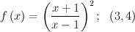
y =

Find the derivative of the function.
f(t) = (1 + √t) (9t² - 7)
f '(t) =

Find the rules for the composite function for g f.

Evaluate h(13), where h = (g f).
h(13) =

Find the derivative of the function.
f(x) = (x³ - 2x)(11x² + 10x)
f '(x) =

Find the derivative of the given function.
f '(x) =

Evaluate f '(x) at the value x = 4.
f '(4) =

Find the slope m of the tangent line to the graph of the function at the given point and determine an equation of the tangent line.
m =
y =

Find the slope and the equation of the tangent line to the graph of the function f at the specified point.
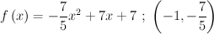
slope
tangent line | y =

Find the slope m and an equation of the tangent line to the graph of the function f at the specified point.
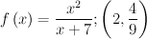
m =
y =

The concentration of a certain drug (in mg/cm³) in a patient's bloodstream t hr after injection is given by the following function.
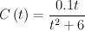
Evaluate the limit.

