The Team selected is Oklahoma City Basket ball Team
Review basketball terms on attached list. (#1)
- • Students will use the Internet to locate their assigned team’s statistics. All required statistics can be found at www.nba.com.
- • Students should produce a hard copy their team's location, as well as their team’s individual players’ season statistics and team roster.

STEP TWO:
- • Students will locate their NBA team on an outline map of the United States as closely as possible to the location of the correct city and state.

STEP THREE:
- • Students will convert the players’ heights given in the Internet tables into inches and the/ages from dates of birth to years. Students will calculate the mean, median, and mode of the players’ heights (in inches), weights, and ages (in years).
- • Students will calculate the total points scored by each player using the formula:
- 2(FGM) + 3(3PM) + 1(FTM) = total points.
- • For each player, they will calculate average points per minute played and average points per game. (See attached worksheets #3 to enter data and calculate measures of central tendency)

STEP FOUR:
- • Students should predict relationships (if any) between pairs of variables below and have them justify their predictions.
- • Students will generate and create scatter plots between the following pairs of variables:
- ▪ age vs. total points scored
- ▪ height vs. total points scored
- ▪ player number vs. total points scored
- ▪ weight vs. total points scored
- • They will generate and create bar graphs between the following potential relationships:
- ▪ position (Guard, Center, Forward) vs. average height of players at those positions
- ▪ position vs. total number of points scored at those positions.

STEP FIVE
- • Students will interpret the graphs generated in Step 4 and to assess whether the relationships obtained represent positive, negative or no evident correlation.

STEP SIX
- • Students will locate a list of player salaries and use that list to relate salaries to points scored, minutes played and points per minute, as well as to calculate costs in dollars per minute played. NBA salaries can be located at http://asp.usatoday.com/sports/basketball/nba/salaries/
- • Students will report on who is the most expensive player in terms of dollars/minute played and who is the “best buy”--the player who costs the least per point scored.
- • Students will conduct a multivariate regression to predict player’s salary from points scored, minutes played, position played, age, height, weight, and player’s number. Discuss findings. Discuss what other variables (if any) should be included in the model.
- • Students will respond to the analytical questions in attachment #6

STEP SEVEN
- • Students will write a summary of their findings.
- • Students will present their findings to the class in week nine.

Performance Assessment:
Each student will be required to assemble a packet containing the following materials:
1. Printout of team and player data from Internet
2. Statistics worksheets
3. U.S. map, with NBA team located
4. Written response for Step #4
5. All graphs listed in Step 4 above
6. Written responses for Step 5
7. Written responses for Step 6
8. Summary of findings
9. Presentation of findings to class•

Attachment #1: A Guide To Basketball Abbreviations
Reading the Statistics
There are two sections to the statistics, averages and totals. Anything with a % is an average for the season. There are 82 regular season games in a season. These statistics do not include playoff games.

Abbreviations | Meaning | Comments
G | Games played
GS | Games started
MPG | Minutes played for the whole season
FGM | Field Goals Made | Each shot taken in the NBA inside the three point line is worth 2 points.
FGA | Field Goals Attempted | All shots taken from behind the three point line. They are worth three points.
3PM | 3 point shots Made
3PA | 3 point shots attempted
FTM | Free Throws Made | Better known as Foul Shots. These players get a free shot from the foul line (which is 15 feet away from the basket) after they have been fouled from a defensive player. Each shot is worth one point.
FTA | Free Throws Attempted

REBOUND SECTION
Abbreviations | Meaning | Comments
OFF | Offensive Rebounds | Rebounds made by a player whose teammate shot the basketball
DEF | Defensive Rebounds | Rebounds made by a player from the opposing team
TOT | Total number of Offensive and Defensive rebounds

OTHER STATISTICS
Abbreviations | Meaning | Comments
A | Assist | A pass from a player to his teammate, and that teammate then scores a basket.
B | Blocks | A block shot

PLAYER ROSTERS
Abbreviations | Meaning | Comments
NUM | The number on the player’s jersey
POS | The position that the player plays
 | G = Guard | The person who dribbles the ball up and shoots from the outside of the basket area. Usually shorter players.
 | F = Forward | The person who plays close to the basket. Usually taller players.
 | C = Center | The person who is the tallest player on the team. Usually plays near the basket.
WT | Weight
DOB | Date of Birth
FROM | Colleges the players attended, and the year they graduated from school or left school.

ATTACHMENT 2: MAP OF THE UNITED STATES
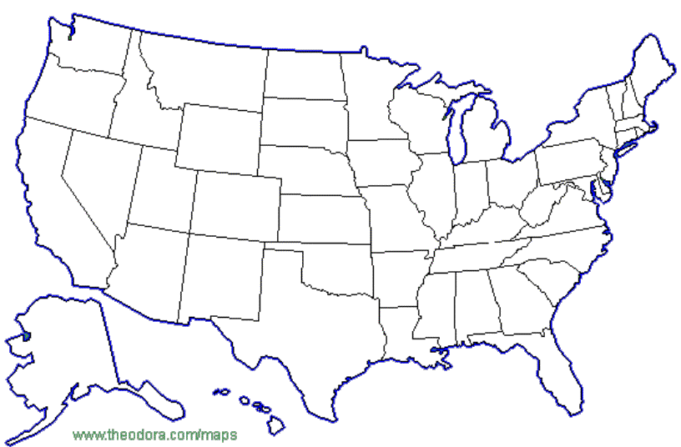

ATTACHMENT #3--Player Data--Conversions of Heights and Ages

NAME__________________________________

NAME OF PLAYER | HEIGHT IN FEET & INCHES | HEIGHT IN INCHES | DOB | AGE IN YEARS | WEIGHT
 | TOTALS
 | MEAN
 | MEDIAN
 | MODE

ATTACHMENT #4--Calculation of Total Points Scored
NAME__________________________

FORMULA = 2(FGM) + 3(3PM) + 1 (FTM) = TOTAL PTS

PLAYER | 2 (FGM) | TOTAL FIELD GOAL POINTS | 3 (3PM) | TOTAL 3 POINT GOALS | 1 (FTM) | TOTAL FREE THROWS MADE | TOTAL POINTS

ATTACHMENT 5: --Calculation of average points/min. and average points/game
NAME__________________________

FORMULA #1: AVERAGE POINTS PER MINUTE =
TOTAL POINTS/ MINUTES PLAYED

FORMULA #2: AVERAGE POINTS PER GAME PLAYED =
TOTALS POINTS/TOTAL GAMES PLAYED

PLAYER | TOTAL POINTS | TOTAL GAMES | TOTAL MINUTES | APM | APG

ATTACHMENT #6 ANALYTICAL QUESTIONS
Answer in complete sentences on a separate sheet of paper.
- Which of the variables you tested were positively correlated with player success as measured by total points scored? Which of these variables appeared to be the best predictor of success? Do these results make sense? Why or why not?
- Were there any variables which were not at all correlated with success on the basketball court? Did these results make sense? Why or why not?
- Were there any variables which were negatively correlated with success? Did these results make sense? Why or why not?
- Based on your data, what would you look for if you were a team manager trying to find the players most likely to score many points for your team? Why?
- Should the team manager choose only those players likely to score the most points? Why or why not? What other factors should he(she) consider?
- Do you think team location is related to success of basketball teams? How could you test your hypothesis?
- Which of your results surprised you? Explain why you were surprised and try to explain why you got the result you did.
- Suggest other variables which might be more strongly correlated with player success on the basketball court than the ones in this experiment.
- Can you predict the success of a team based on the statistics of the individual players?

