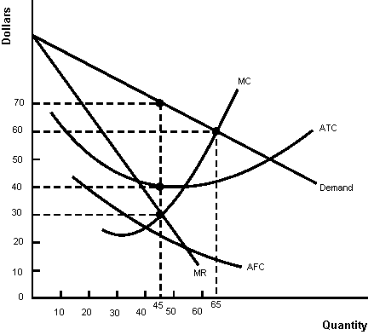
Cost and Demand Conditions of a Monopolist
- The profit-maximizing level of output for the monopoly is

- The profit-maximizing price for the monopoly is

- At the profit-maximizing output, the monopolist's total revenue equals

- At the profit-maximizing output, the monopolist's total cost equals

5. If the monopoly maximizes profit, profit will equal

