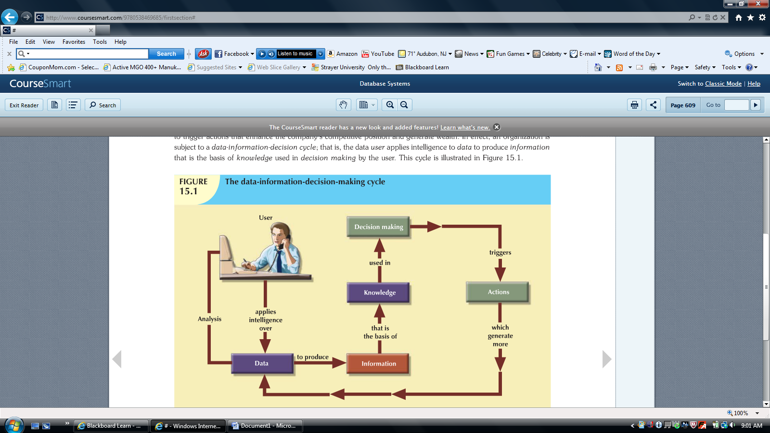

To assess data’s monetary value, take a look at what’s stored in a company database: data about customers, suppliers, inventory, operations, and so on. How many opportunities are lost if the data are lost? What is the actual cost of data loss?
For example, an accounting firm whose entire database is lost would incur significant direct and indirect costs. The accounting firm’s problems would be magnified if the data loss occurred during tax season. Data loss puts any company in a difficult position. The company might be unable to handle daily operations effectively; it might be faced with the loss of customers who require quick and efficient service, and it might lose the opportunity to gain new customers.
Data are a valuable resource that can translate into information. If the information is accurate and timely, it is likely to trigger actions that enhance the company’s competitive position and generate wealth. In effect, an organization is subject to a data-information-decision cycle; that is, the data user applies intelligence to data to produce information that is the basis of knowledge used in decision making by the user.

