- Write a structural formula for each of the following compounds:
  - N,N-diethylaminocyclopentane
  - ethylpropylamine
  - tetramethylammonium hydroxide
  - 1,3-diaminobutane
- Write a correct name for each of the following compounds:
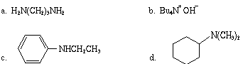
- Draw the structures for and name and classify as primary, secondary, or tertiary all the isomeric amines with the molecular formula C₅H₁₃N.
- Give equations for the preparation of the following amines from the indicated precursor.
  - 1-aminohexane from 1-bromopentane
  - N-butylaniline from aniline
- Complete the following equations.
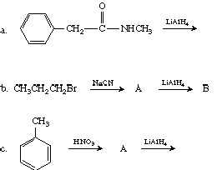
- Tell which is the stronger base and why.
  - aniline or o-bromoaniline
  - aniline or cyclohexylamine
- Write an equation for the reaction of
  - trimethylamine with HBr
  - cyclopentylamine with HCl
- Illustrate the amphoteric nature of amino acids by writing an equation for the reaction of proline in its dipolar ion form with an equivalent of
  - hydrochloric acid, HCl
  - sodium hydroxide, NaOH
- Write the formula for each of the following in its dipolar ion form.
  - leucine
  - threonine
  - methionine
  - tyrosine
- Write equations for the reaction of phenylalanine with
  - CH₃CH₂OH and H⁺
  - C₆H₅COCl and base
  - acetic anhydride

