1. Find the equation of the regression line for the given data. Predict the value of Y when X=-2? Predict the value of Y when X = 4?
2. The data below are the final exam scores of 10 randomly selected statistics students and the number of hours they studied for the exam. Find the equation of the regression line for the given data. Predict the final exam score when a student studied for 4 hours. Predict the final exam score when a student studied for 6 hours.
3. A manager wishes to determine the relationship between the number of miles (in hundreds of miles) the manager's sales representatives travel per month and the amount of sales (in thousands of dollars) per month. Find the equation of the regression line for the given data. Predict the value of sales when the sales representative travel 8 miles. Predict the value of sales when the sales representative traveled 11 miles.
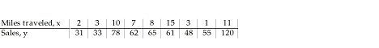
4. Find the correlation coefficient between X and Y. Is there a weak or strong, positive or negative linear correlation between X and Y?
5. The data below are the final exam scores of 10 randomly selected statistics students and the number of hours they studied for the exam. Find the correlation coefficient between hours studied and final exam scores. Is there a weak or strong, positive or negative correlation between hours studied and final exam scores?

