Problem:
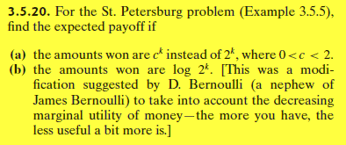

Here below is the example 3.5.5 to being used as reference:
