- Write a structural formula for each of the following compounds:
  - 2,3-dimethyl-2-pentanol
  - 2-methyl-3-penten-1-ol
  - m-nitrophenol
  - potassium butoxide
- Name each of the following compounds.
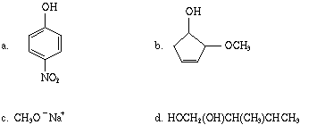
- Arrange the following compounds in order of increasing acidity, and explain the reasons for your choice of order.
  - 2,4-dinitrophenol
  - phenol
  - 2,4-difluorocyclohexanol
  - cyclohexanol
- Complete each of the following equations and name the products.
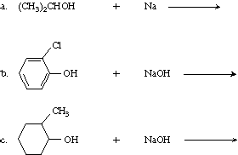
- Show the structures of all possible acid-catalyzed dehydration products of the following. If more than one alkene is possible, predict which one will be formed in the largest amount.
  - 2-methyl-2-butanol
  - 1-methylcyclohexanol
- Write an equation for each of the following reactions:
  - propanol + PBr₃
  - 2-butanol + CrO₃, H⁺
  - 2-methyl-1-pentanol + HCl
  - 1-butanol + SOCl₂
  - 1-butanol + aqueous NaOH
- Treatment of 3-hexene-2-ol with concentrated HCl gives a mixture of two products, 2-chloro-3-hexene and 4-chloro-2-hexene. Write a reaction mechanism that explains how both products are formed.
- Write an equation for the two-step synthesis, 1-pentene to 2-pentanone.

