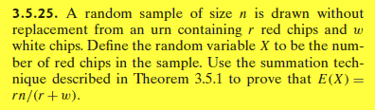
Note: Theorem 3.5.1 is given below:
$$E\left(X\right)=\sum_{all k}{k ∙ p_{x}(k)}$$

