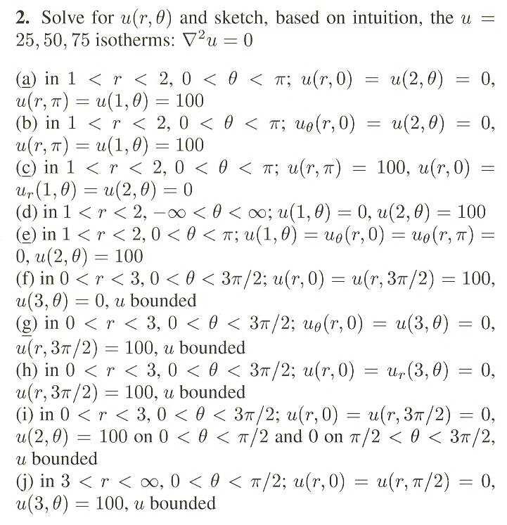

(Please solve for only part f.)
(The problem is from Separation of Variables; Non-Cartesian Coordinates.)

