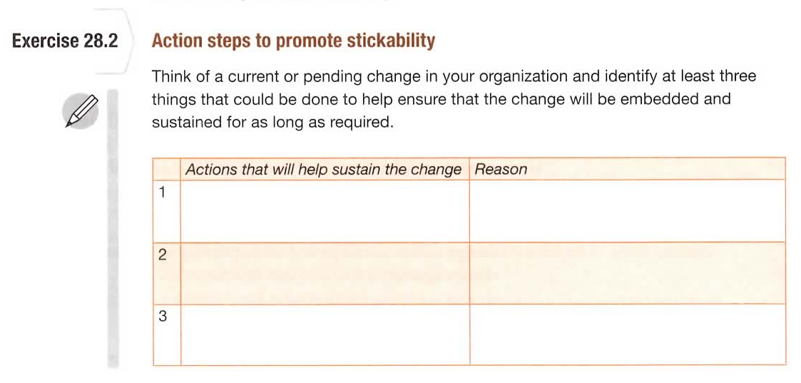
List as many actions as you like along with a reason as well.

