1. Consider the periodic pleural pressure source plotted below:

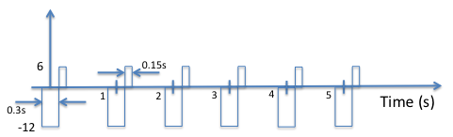

The negative going pressure pulse has a magnitude of -12 cmH2O and a duration of 0.3s. The positive going pressure pulse has a magnitude of 6 cmH2O and a duration of 0.15s and begins immediately after the negative going pressure pulse.

1. Write an algebraic expression for the negative going pressure pulses as a convolution between a *rect*() function and a sum of delta functions.  
   should be in this format
2. Write an algebraic expression for the positive going pressure pulses as a convolution between a *rect*() function and a sum of delta functions.  
   should be in this format
3. Find the Fourier transform of the composite presure pulse by summing the positive- and negative-going components and find the algebraic expression of each (positive and negative going components).