Please consider the following information for the next questions
Expected payoff corresponding to various levels of business expansion and economic conditions faced by Ramcast Cable Inc. is given in the table below. The probabilities of the events are also given. What is each expected monetary value (EV) of each alternative below, and the maximum expected monetary value (EV) in the payoff matrix given:
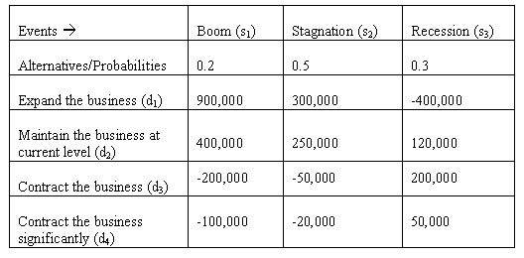
- If we expand the businesss, what should be the expected EV?
- If we maintain current levels, what should be the expected EV?
- If we contract the business, what should be the expected EV?
- If we contract the business significantly, what should be the expected EV?
- Which of the four options above has the highest EV?
Please enter your answer as a whole number. No dollar signs or commas

