Lecture notes: Three Classic Leadership Styles
The earliest research on leadership styles was conducted by Kurt Lewin (1939) and his students who identified three basic styles: autocratic, democratic, and laissez-faire. The autocratic style is directive, assertive, aggressive, and controlling in relationships. Leaders with an autocratic style use strict policies and procedures to control the work environment. Followers have little power and are unable to challenge authority. The leader with a democratic style is open-minded, interactive, egalitarian, collaborative, and focuses on policies and procedures less than the autocratic leader. Followers are a part of the decision making process at all levels. The leader with a laissez-faire style uses a hands-off approach, gives followers a significant amount of autonomy to complete tasks, determine goals, make decisions, and focuses on policies and procedures less than the democratic leader. The laissez-faire style can be “risky” and can create chaos for followers due to a lack of supervision.
Classic Leadership Styles

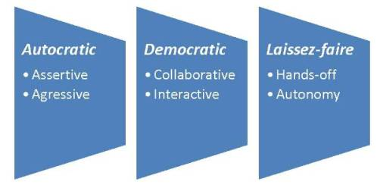

A general in the military may have an autocratic style of leading, a dean of a college may have a democratic style of leading, and a retail manager may have a laissez-faire style of leading. Over the years, there have been many debates over leadership styles and what the optimum leadership style is.

Please begin by reading:
Leadership Toolbox. (2008). Leadership styles: Democratic leadership style. Retrieved May 14, 2011 from http://www.leadership-toolbox.com/democratic-leadership-style.html
Leadership Toolbox. (2008). Leadership styles: Autocratic leadership. Retrieved May 14, 2011 from http://www.leadership-toolbox.com/autocratic-leadership.html
United Nations Public Administration Network. (2010). Leadership styles. Retrieved May 14, 2011 fromhttp://unpan1.un.org/intradoc/groups/public/documents/unssc/unpan024704.pdf
Assignment:
Then, drawing on the material in the background readings and doing additional research, please prepare a 5-6 page paper (not including the cover and reference pages) in which you:
- Research the company REI (starting with Fortune Magazines “Top 100 Companies to Work For 2011” http://money.cnn.com/magazines/fortune/bestcompanies/2011/full_list/ ), then answer the following questions:
  - Which of the classical leadership styles exemplifies this company?
  - What is the added value of this leadership style?
  - What impact does this leadership style have on the organization’s overall image?
  - Contrast this leadership style with United Airlines, named the worst company in America to work for by glassdoor.com.
  - Based on your experiences and research, what kind of leadership style is needed to promote efficiency in an organization? What contingencies affect this outcome? Justify your response.

Assignment Expectations
Your paper will be evaluated on the following points:
- Precision - Does the paper address the question(s) or task(s)?
- Clarity - Is the writing clear and the concepts articulated properly? Are paraphrasing and synthesis of concepts the primary means of response to the questions, or are excessive use of quotations how thoughts are conveyed? Are headings included in all papers greater than 2 pages?
- Breadth - Is the full breadth of the subject addressed?
- Depth - Does the paper address the topic in sufficient depth?
- Grammar, spelling and vocabulary - Is the paper written well - is the grammar, spelling, and vocabulary suitable to graduate level work?
- Referencing (citations and references) - Does the paper use citations and quotation marks when appropriate?
- Critical thinking - Is the subject thought about critically, i.e., accurately, logically, relevantly, and precisely?

