Week 4: Conflict and Communication - Lecture

Communication and Conflict
What is Communication? | The Communication Process | Organizational Communication | Conflict | Self-Test
What is Communication?
Communication is the process by which information is exchanged and understood by two or more people, usually with the intent to influence or motivate behavior. Communication can also be defined as the process of interaction through which meaning is shared, consciously or unconsciously, verbally or nonverbally, with another. Nonverbal communication is an important part of communication media, and it can be more powerful than words or voice. In some instances, nonverbal communication can completely change the meaning of words.
The Communication Process

Figure 1: The Communication Process and possible sources of noise.
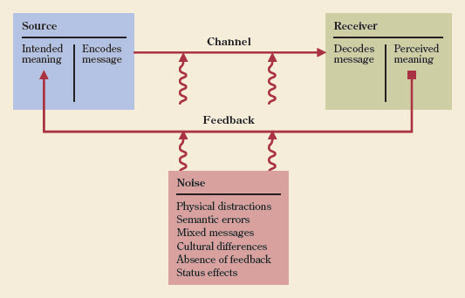

Communication consists of seven essential components:
1. Sender (communicator)
2. Message
3. Encoding
4. Channel
5. Decoding
6. Receiver
7. Feedback
The sender initiates the message by encoding a thought. Encoding involves the selection of words, symbols, or gestures used to compose a message. The message is the tangible formulation of an idea to be sent to the receiver. The channel is the carrier of the message, which can be either formal or informal. Once the receiver receives the message, words, symbols, or gestures, it must be comprehended. This process is called decoding the message, which involves the translation of information used in the message for the purpose of interpreting its meaning. The final link in the communication process is a feedback loop. Feedback is verification of whether the message transferred as intended, and it confirms whether understanding has been achieved. Without feedback, the communication process is one-way.
In organizations, communication is the lifeline of effective management and leadership. Through the communication process, an individual, group, or organization may succeed or fail in attaining goals. Contemporary organizations spend massive resources educating their workforces on topics such as writing with clarity, making presentations, and resolving interpersonal and group conflict. In more recent years, organizations have focused on various forums of electronic communication, such as video conferencing, audio conferencing, electronic meetings, and e-mail meetings. Nevertheless, failure to communicate effectively and well continues to be a major challenge for many organizations.

Organizational Communication
Organizational communication is highly influenced by corporate culture. For example, some organizations embrace a strict adherence to the chain of command and employ primarily downward communication through formal channels. Standard examples of downward communication are published company goals and strategies, published procedural manuals, and structured performance feedback.
Other organizations are less conscious of a strict hierarchy and employ more upward and lateral communication with both formal and informal communication channels. Examples of upward communication include escalated problems and/or grievances and suggestions for improvement. Lateral communication consists of information flowing among members at the same organizational level. Examples of horizontal communication would be information exchange between peers within the same work group or exchanges across departmental lines seeking problem resolution for a client.
In most organizations, senior managers set the tone by how they choose to communicate and disseminate information through an organization’s formal channels. In all organizations, informal communication channels exist (grapevine, water-cooler). They can be vital channels for information flowing through an organization.
In addition, the use of collaborative software is becoming more and more common in businesses. We’ve touched on e-mail, but other “collaborative” software examples include shared calendaring systems, wikis, internal bulletin boards, and blogs.
As Facebook and YouTube have revolutionized social networking and social group communication, the rise of collaborative technologies within companies can improve communication by reducing reliance on siloed formal communication channels, and can help defuse the negative effects that status differences can have on successful communication. These tools can significantly improve information circulation and sharing, and can help eliminate “information as power” approaches to management.
However, all forms of electronic communication have their own challenges, not the least of which is that the messages are given and received in the absence of any physical or emotional context (body language, inflection). Given the nature of our virtual classroom and our previous discussions on virtual teams, we have already discussed some of these difficulties in depth. Despite the lack of richness we are witnessing, there is an increasing tendency for people to opt for sending an electronic communication instead of meeting face-to-face or communicating via phone.
Remember Google’s third golden rule for high performance?
Pack them in – put people to work close to one another (Hunt, Osborn, Schermerhorn, & Uhl-Bien, 2010).
The “rule” seems squarely aimed at the desire to have colleagues actually talk to one another in a dynamic exchange rather than conduct less rich conversations via e-mail chains stripped of context. Google sits clearly in the center of the electronic information-sharing universe. It is an outstanding example of how employers and employees alike need to remember to value the individual and the personal, and not lose sight of the fact that sending more information through electronic media with no feedback and no context is not necessarily a communication improvement. Without feedback and context, it may not be effective communication at all.
Conflict

Despite our best efforts at communication, we inevitably encounter conflict of some description. Substantive conflict occurs when there are disagreements on matters of substance (goals, objectives, strategies, etc.), and emotional conflict occurs when interpersonal difficulties arise (anger, mistrust, fear, etc.).
Figure 2: Five direct conflict management strategies.
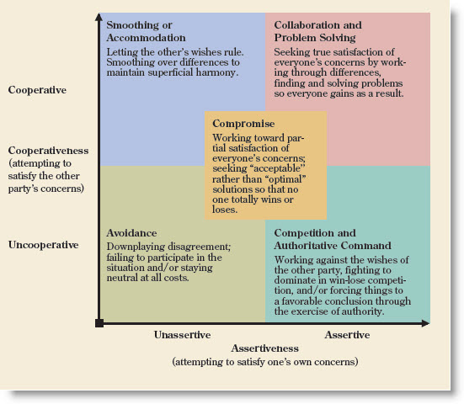

Despite what you may think, not all conflict is bad. In an organization with no conflict at all, it would seem likely that new ideas weren’t being generated, or, if they are, they aren’t getting a critical review. Functional conflict results in positive benefits (possible solutions to a problem are debated to arrive at the best solution). Dysfunctional conflict works to the group’s or organization’s disadvantage (e.g., two team members have a personal dislike for one another and do not properly share resources, thereby slowing team progress). Working in any organization, we will encounter conflict and a manager’s job is frequently to diffuse or manage conflict.
Indirect conflict management is called for when behavioral changes cannot solve the conflict at hand. People really can have “irreconcilable differences,” and in those cases there needs to be a structural approach to resolving an issue. There are four indirect approaches described well in the text: reduced interdependence (change a process so the conflicting parties do not have to directly interact); appeals to common goals (remind people of a shared goal to alleviate petty squabbling); hierarchical referral (ask the boss, or the courts, to make a decision); and altering scripts and myths (breaking down institutional behaviors or debunking company folklore).
Direct conflict management is the process of addressing conflict face-to-face. There are five primary conflict management strategies. Our text summarizes the strategies with the chart displayed in Figure 2, which does a good job of defining the strategies and explaining them against cooperative and assertive axes.
By analyzing the chart, we can break the strategies into “win-lose” categories depending on the results. Unfortunately, there are more “lose-lose” results than other types. Avoidance, smoothing, and compromise all result in no one really getting their desired results; therefore, they are “lose-lose.” The situation is avoided altogether, swept under the rug, or a compromise is reached where everyone shares in the “loss” of not getting the desired result. We tend to think of compromise as a “good” resolution to a conflict, when, in fact, what it does is spread around the “loss” to all parties involved. It does work as a strategy, but it is not optimal. Competition and authoritative command clearly result in a “win-lose” result. Conflict “resolved” in this manner is often simply conflict deferred. The root cause of a problem isn’t resolved and it is likely to present itself again. The one “win-win” strategy is collaboration and problem solving.
While that may sound similar to “compromise,” there is a significant difference. In a true collaboration, the parties work together in an open and honest atmosphere and collectively reach a permanent solution to the conflict. Collaboration is time consuming, and very difficult in organizational cultures that value competition or power.
I look forward to our collaboration in the threads this week!
Osborn, R.N., J.R., Hunt, J.G., Schermerhorn, & Uhl-Bien, M. (2010). The Communication Process and Possible Sources of Noise [Figure 11.1]. Organizational Behavior. Hoboken, NJ: John Wiley & Sons.

