1.
Simplify: 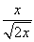
A) 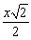
B) 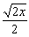
C) 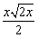
D) 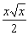
2.
Find the x-intercept:
A)
B)
C)
D)
3.
One of the factors of is:
A)
B)
C)
D)
4.
Add: 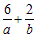
A) 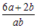
B)
C) 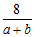
D) 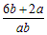
5.
How many feet of fencing should be purchased for a rectangular garden that is 17 ft. long and 16 ft. wide?
A) 272 ft.
B) 132 ft.
C) 66 ft.
D) 33 ft.
6.
Simplify:
A)
B)
C)
D)
7.
Write 0.000097717 in scientific notation.
A)
B)
C)
D)
8.
Solve the following equation for y.
A)
B)
C)
D)
9.
Write 130% as a fraction in simplified form.
A) 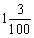
B) 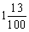
C)
D)
10.
Multiply.
A)
B)
C)
D)
11.
One of the factors of is:
A)
B)
C)
D)
12.
Solve:
A)
B)
C)
D)
13.
Solve:
A) 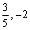
B)
C)
D) 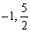
14.
Simlify: 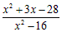
A) 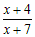
B) 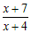
C) 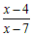
D) 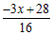
15.
Change 7.39 to a percent.
A) 73.9%
B) 0.0739%
C) 7.39%
D) 739%
16.
A life insurance policy costs $8.52 for every $1000 of insurance. At this rate, what is the cost for $20,000 worth of life insurance?
A) $170.40
B) $117.37
C) $2347.42
D) $20
17.
Evaluate when
A) 28
B) 40
C) -52
D) -40
18.
Simplify:
A) 18
B) 258
C) 66
D) 786
19.
Divide.
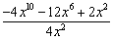
A) 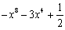
B) 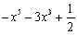
C)
D)
20.
Convert 20 yards to feet.
A) 6.7 feet
B) 180 feet
C) 240 feet
D) 60 feet
21.
Find the slope of the line:
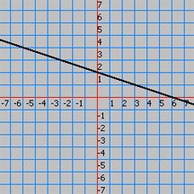
A)
B)
C)
D)
22.
David borrowed $15,000. The term of the loan was for 5 years, and the annual simple interest rate was 7.4%. Find the simple interest due on the loan.
A) $7,500
B) $1,480
C) $222
D) $5,550
23.
Artificial turf is being used to cover a playing field. If the field is rectangular with a length of 100 yards and a width of 70 yards, how much artificial turf must be purchased to cover the field?
A) 3500 sq. yds.
B) 170 sq. yds.
C) 340 sq. yds.
D) 7000 sq. yds.
24.
Divide: 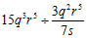
A) 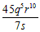
B) 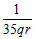
C)
D)
25.
( 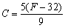)
A) 66.3
B) 104.3
C) 34.4
D) 70
26.
Sales of frozen pizza for a club fund-raiser increased from $500 one year to $565 the next year. What was the percent of increase?
A) 11.5%
B) 13%
C) 88.5%
D) 8.7%
27.
Mark travels 9 miles East and then 12 miles North. How far is Mark from the starting point?
A) miles
B) 11 miles
C) 15 miles
D) 21 miles
28.
Convert 61.1 gal to L.
(Use 1 gal 3.8 L)
A) 16.1 L
B) 64.8 L
C) 57.8 L
D) 231.3 L
29.
One of the factors of is:
A)
B)
C)
D)
30.
One of the factors of is:
A)
B)
C)
D)
31.
Graph: 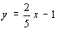
A) 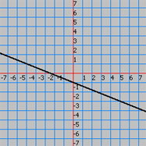
B) 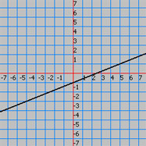
C) 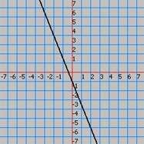
D) 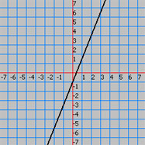
32.
Write 36.3% as a decimal.
A) 36.3
B) 0.363
C) 0.0363
D) 3,630
33.
Simplify:
A) 45
B) 202.5
C) 22.5
D) 14
34.
Simplify:
A)
B)
C)
D)
35.
Solve and Graph:
A)
B)
C)
D)

Time

