Kurose, James F.; Keith W. Ross (2011-03-10). Computer Networking: A Top-Down Approach (5th Edition) (Kindle Location 7550). Pearson HE, Inc.. Kindle Edition.
Network Layer
P4. Consider the network below. a. Suppose that this network is a datagram network. Show the forwarding table in router A, such that all traffic destined to host H3 is forwarded through interface 3. b. Suppose that this network is a datagram network. Can you write down a forwarding table in router A, such that all traffic from H1 destined to host H3 is forwarded through interface 3, while all traffic from H2 destined to host H3 is forwarded through interface 4? (Hint: this is a trick question.) c. Now suppose that this network is a virtual circuit network and that there is one ongoing call between H1 and H3, and another ongoing call between H2 and H3. Write down a forwarding table in router A, such that all traffic from H1 destined to host H3 is forwarded through interface 3, while all traffic from H2 destined to host H3 is forwarded through interface 4. d. Assuming the same scenario as (c), write down the forwarding tables in nodes B, C, and D.
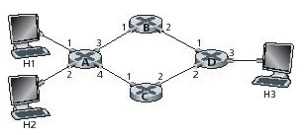
P6. In the text we have used the term connection-oriented service to describe a transport-layer service and connection service for a network-layer service. Why the subtle shades in terminology?

P8. Consider the switch shown below. Suppose that all datagrams have the same fixed length, that the switch operates in a slotted, synchronous manner, and that in one time slot a datagram can be transferred from an input port to an output port. The switch fabric is a crossbar so that at most one datagram can be transferred to a given output port in a time slot, but different output ports can receive datagrams from different input ports in a single time slot. What is the minimal number of time slots needed to transfer the packets shown from input ports to their output ports, assuming any input queue scheduling order you want (i.e., it need not have HOL blocking)? What is the largest number of slots needed, assuming the worst-case scheduling order you can devise, assuming that a non-empty input queue is never idle?
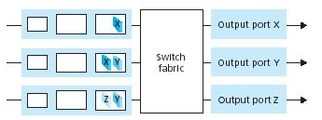
P12. Consider a router that interconnects three subnets: Subnet 1, Subnet 2, and Subnet 3. Suppose all of the interfaces in each of these three subnets are required to have the prefix 223.1.17/24. Also suppose that Subnet 1 is required to support up to 63 interfaces, Subnet 2 is to support up to 95 interfaces, and Subnet 3 is to support up to 16 interfaces. Provide three network addresses (of the form a.b.c.d/x) that satisfy these constraints.

P17. Consider sending a 2400-byte datagram into a link that has an MTU of 700 bytes. Suppose the original datagram is stamped with the identification number 422. How many fragments are generated? What are the values in the various fields in the IP datagram(s) generated related to fragmentation?

P18. Suppose datagrams are limited to 1,500 bytes (including header) between source Host A and destination Host B. Assuming a 20-byte IP header, how many datagrams would be required to send an MP3 consisting of 5 million bytes? Explain how you computed your answer.

P22. Looking at Figure below, enumerate the paths from y to u that do not contain any loops.
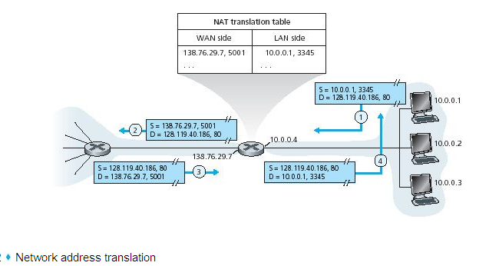

P. 24Consider the following network. With the indicated link costs, use Dijkstra’s shortest-path algorithm to compute the shortest path from x to all network nodes. Show how the algorithm works by computing a table similar to Table 4.3.
Network:
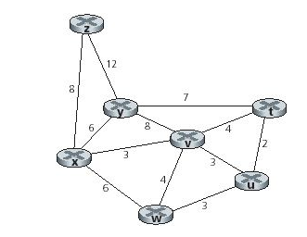

Reference:
