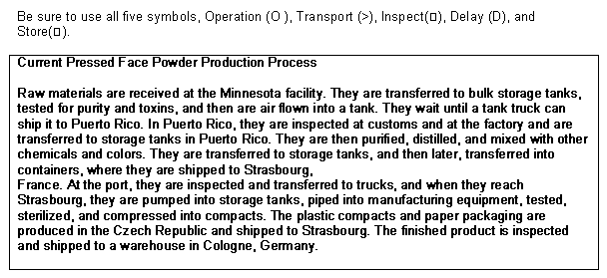
After all of the setbacks that Smitheford Pharmaceutical has been through, they have always managed to come out smelling like a rose. With everything that they have done, Smitheford has been able to successfully expand globally as well as locally. With the upgrades that they have done at the Pueblo Facility, the orders are starting to come in rapidly. Since the recent order to manufacture the Ultamycin drug, they have been chosen to open a new line of cosmetics. Cosmetics right now for some women is a household name and if Smitheford does thing right they can do the cosmetics they have to do on hand now and maybe think about opening their market to other types of cosmetics.
In order to get started with their first cosmetic order, Smitheford needs to make sure they meet all of the deadlines not only with the first plant but for the other two plants along with going through Customs as well with the least amount of risks and issues of waste. Waste in an Organization is not just garbage and other types of rubbish; it is also the extra steps or processes that are in a task which takes up a lot of company time. In Organization Process Maps, waste is unnecessary steps, storage, or other hold times keeping a product from the continuation of its manufacturing. If for some reason the next Work in Progress team is not ready to go to the next level of the product and those products sits in storage or remain in an idle time mode that is considered waste.
When we waste company time in a Manufacturing Organization, we also waste precious company money. If we waste company money then that means that our company is also losing Revenue. Speaking of waste, looking at the process entailed in the production of the Pressed Face Powder, there may be a chance that someone will get mixed up on which route they should to press forward to a finished product. In order to explain things further, we will incorporate the data in the box below into an actual Streamline Process map.
When looking at this data process, we see that there are at least fourteen (14) different processes starting from the Raw Materials in Minnesota and ending at the Finished Product in Cologne, Germany. This many processes can not only cause a team to miss one step but also when the step is skipped the company would have to start the whole process from the beginning which will be time-consuming and money loss for the business. But we will now take a look at what these fourteen (14) processes looks like in the actual Process Map.
Old Process for Face Powder
New Process for Face Powder
In looking at the above process, we see a lot of unnecessary storage and inspections which could and would take a big bite out of your goals deadline. When manufacturing much needed products with a deadline at stake, it is important to route the process making sure to take advantage of all unused time. Having time management while remaining efficient in order to have quality finished goods on time for the consumers’ satisfaction. There are a total of three plants being used for the process of turning these raw goods into finished goods. Our main facility is located in Minnesota and the other two are located in Puerto Rico and Germany. It seems that after each task is completed, the Work-in-process products are delayed from go to the next phase. In thinking about the reason for this, it means that either employee production levels are not where they should be or for some reason they are backlogged on orders. For whatever the reason is, delays like this will not only through off the whole process going on but will eventually continue to be delays in everything that is worked on unless the problem is handled right away.
To better explain how the process should be, we will create a new process map without the extra waste to show how uncongested things could be. First off, Smitheford should assign more resources to the production lines to make sure that every point of WIT points has someone filling in that position to keep the flow of production moving at a timely fashion. When one area is done with their part and send the product to the next area, the next step should be started right away. Before the products are shipped to the next plant, scheduling should make sure that all schedules are done to promptly go from the WIP line out to the shipping area where the orders and invoices are printed on time and products loaded in the trucks or whatever mode of transpotation being used. It is not necessary to Inspect before work is started and after you are done. When shipments arrive to the plant, the receiving and inventory staff will check everything to make sure nothing is missing before they sign for receipt. and accurately schedule transfer of the goods without to big of wait time. Also, if each plant has a detailed checklist of what they are to do it will cut out the extra process of having to duplicate things or overdoing things at the next plant.

