Be sure to use all five symbols, Operation, Transport, Inspect, Delay and Store.
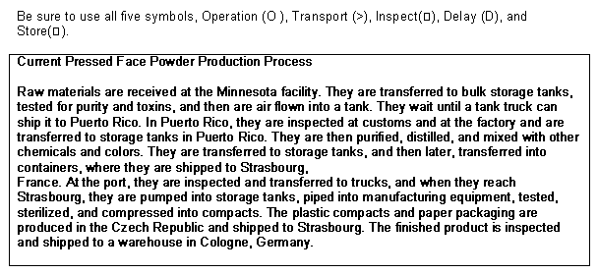

Raw materials are received at the Minnesota facility. They are transferred to bulk storage tanks, tested for purity and toxins, and then are air flown into a tank. They wait until a tank truck can ship it to Puerto Rico. In Puerto Rico, they are inspected at customs and at the factory and are transferred to strage tanks in Puerto Rico. They are then purified, distilled, and mixed with other chemicals and colors. They are transferred to storage tanks, and then later, transferred into containers, where they are shipped to Strasbourg, France. At the port, they are inspected and transferred to trucks, and when they reach Strasbourg, they are pumped into storage tanks, piped into manufacturing equipment, tested, sterilized, and compressed into compacts. The plastic compacts and paper packaging are produced in the Czech Republic and shipped to Strasbourg. The finished product is inspected and shipped to a warehouse in Cologne, Germany.

