Homework
Due 2/26/12
1. CNP Bank Card
Before banks issue a credit card, they usually rate or score the customer in terms of his or her projected probability of being a profitable customer. A typical scoring table appears below.
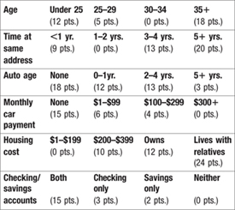(K)
The score is the sum of the points on the six items. For example, Sushi Brown is under 25 years old (12 pts.), has lived at the same address for 2 years (0 pts.), owns a 4-year-old car (13 pts.), with car payments of $75 (6 pts.), housing cost of $200 (10 pts.), and a checking account (3 pts.). She would score 44.
p. 263
A second chart is then used to convert scores into the probability of being a profitable customer. A sample chart of this type appears below.
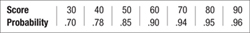(K)
Sushi's score of 44 would translate into a probability of being profitable of approximately .81. In other words, 81 percent of customers like Sushi will make money for the bank card operations.
Here are the interview results for three potential customers.
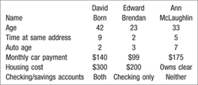(K)
- Score each of these customers and estimate their probability of being profitable.
- What is the probability that all three are profitable?
- What is the probability that none of them are profitable?
- Find the entire probability distribution for the number of profitable customers among this group of three.
- Write a brief summary of your findings.

