This assignment is based of the following questions below:

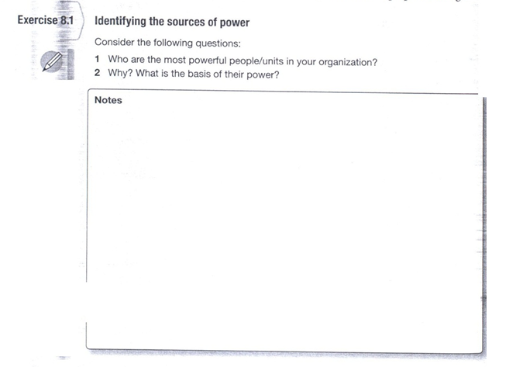

Below are three response that were submitted based on the two questions above, all that I require is some assistance with the response to each of the three responses below:

First response by: A.S.

1. The most powerful people in the school I work at related to my position are:
a. Teachers
b. Principals
c. Parents
And while there are other important people/units, these three groups are the ones that most directly effect my work on a day-to-day basis.
2. To start, parents are powerful in their children's lives. What they do at home carries over into their school day and school work. I could write an exhaustive list of examples of students I work with who are failing in one or more classes because of issues involving their parents at home. Some of the parents don't even realize the power they have over their student's success and future. The parents are in a position to deal with important problems related to their child and the local school system.
Principals have control over significant resources and are centrally connected in the work flow of the organization. Recently I began working with a student who's mother just suffered a major stroke and was expected to function at the level of an 8 year old. The freshman student was failing in all his classes. This major life trauma coupled with his previous hatred of all things school were a recipe for disaster. Then one beautiful winter morning he came to school with a Satanic shirt on (upside down cross). He was sent to the principals office, suspended from school, and upon returning to school got 45 days of detention during lunch (part of this was the lively altercation he had with the principal...the student felt his freedom of speech was being taken, and Christian kids who wear crosses aren't suspended even though it offends him, etc.). After finding all this out I went to the AP and requested that the student be let out of detention to come work with me to improve his grades during lunch instead of squandering the time away in the detention room. At that moment the AP had the power and control to allow this student to work with someone to do something positive or make the student "learn a lesson" for his choice words during the t-shirt confrontation. And, in case you're wondering, he was allowed to work with me.
Teachers have the power to work with
______________________________________________________________________________
Please provide a response to the posting provided above.
______________________________________________________________________________
Second response by: M.W.

1. Who are the most powerful people/units in your organization?
- I work in a public school system, this means that there are a number of powerful people in my organization. By ‘organization’, I mean my school district, as well as the school where I work. Each entity on the list has the ability to enact change that would cause ripples and conflict in other areas throughout the organization.
- The top 5 most powerful people/units in or affiliated with my organization are:
i. Parents
ii. Superintendent
iii. School board
iv. Teacher’s Union
v. Principals
vi. Governor Walker (#pukeface) –I reluctantly add Walker as my 6th most powerful person in my organization because as governor, he influences all of the other people on my list to “…change the behavior of other.” (Hayes, 2010, p.144) The definition of power according to Hayes is, “It is the ability to cause others to perform actions they might not otherwise perform” (Hayes, 2010, p.144)
2. Why? What is the basis of their power?
- The people on the list above are the most powerful because of their formal and informal power. Each entity on the list has the ability to use organizations as political arenas because they push their individual agendas via the school and school district.
- Parents have the ability to put pressure on the superintendent, the school board, as well as principals if they have an agenda that they are really supporting or opposing. Basis of power: are centrally connected in the work flow of the organization, are not easily replaced, have successfully used power in the past
- The Superintendent sets the overall agenda for the entire school district as well as for each individual school. They have the ability to implement changes that will produce their desired outcome. Superintendents also have the ability to end programs and take money away from programs that might cause them to die down and not be as effective if the superintendent does not want to just end the program outright. Basis of power: are in a position to deal with important problems facing the organization, has control over significant resources valued by others, are centrally connected in the work flow of the organization, have successfully used power in the past, are lucky or skilled enough to bring problems and resources together at the same time
- The school board chooses the superintendent and the board has the power to sanction the superintendent if needed. They are also responsible for hiring each superintendent as well, so the board has a considerable amount of power and authority. Basis of power: are in a position to deal with important problems facing the organization, have successfully used power in the past
- Principals have the ability to make changes within their designated school as long as those changes are on par with what they superintendent wants as well as what parents and the teacher’s union want as well. This is probably the most tricky of all the entities on the list because of their day-to-day contact with union reps, teachers, parents, as well as the office of the superintendent. Basis of power: are in a position to deal with important problems facing the organization, has control over significant resources valued by others, are centrally connected in the work flow of the organization, have successfully used power in the past, are lucky or skilled enough to bring problems and resources together at the same time
- The teacher’s Union is the most complicated entities on the list. The union, as it stands until June 30, 2013 (when the current MPS contract ends), has the ability to enact change, stop change, encourage change, support change, make decisions for all teachers. Their influence causes the superintendent, principals, and the school board take notice and confer with the union before any major change is enacted. Failure to do so could cause all sorts of conflicts between all of the power brokers inside of my organization. Basis of power: has control over significant resources valued by others, are centrally connected in the work flow of the organization, have successfully used power in the past, are lucky or skilled enough to bring problems and resources together at the same time, have control of resources valued by others
- Governor Walker was an agent of change in Wisconsin by implementing changes that will affect schools everywhere. While he isn’t technically inside of my organization, his office does control how public school monies are divided up. Taking $800million+ from public education will greatly affect my school district. Basis of power: have control over significant resources valued by others, have successfully used power in the past.
Hayes, J. (2010). The Theory and Practice of Change Management (Third ed.). New York, New York: Palgrave Macmllan.

Please provide a response to the posting provided above.

Third response by: H.B.
My current organization is very small. We have a total of five employees (three full-time, one intern, and one remote that does some admin work on a part-time basis), so I would have to say the most powerful person is the owner of the company (Stacy) even though she won’t admit to having any power. The owner is a good friend of mine and she started her own consulting/contracting business in 2005 to get away from the typical power struggles within organizations. She started her own business after experiencing some interesting power struggles at two small companies that both she and I had worked at.
Approximately two years ago Stacy had more work than she could handle and I was looking to move on from where I was. So, I took the chance that I would also be able to bring in work for the business and started working for her. In this environment the three of us that are full-time each have the power to bring in work and manage our own time and projects. The lack of internal power struggles and flexibility makes for a very pleasant work environment.
As mentioned before, Stacy and I have worked together at two separate companies in the past and some of the experiences from each of the organizations helped her to make the decision to start her own business. Each organization was structured differently and each had their own internal power structures as described below.
Company A was a small (around 20 employee) family owned system integration business. The president and owner’s power came from his position and how he communicated with the employees. His communication method was intimidation…everyone was afraid to make a mistake and if they did, everything was done to remedy or cover that mistake before the owner found out. Power among the employees came from the ownership of information and not sharing that information with co-workers. Essentially, whoever had the most and/or current information on a project was the one who had the power for the moment. The ownership of power changed depending upon who held information, so the sharing of information did not happen freely at this company. It was a difficult place to work due to the tide of power changing depending upon who was the holder of information. I personally felt if everyone would just share what they knew the company would be stronger as a whole.
Company B was another small (around 10 -15 employee) system integration business. The organizational structure of Company B differs greatly from Company A. I would equate this organization to a bee hive. There is the primary owner/president whose personality has the power to sell the business and bring in clients. The vice president’s official position is to handle the financial end of the business and her power came in the form of being the “Queen Bee”. Having a Queen Bee basically run the office created a difficult working environment for all but even a little more so for female employees because she would do things to undermine them. Queen Bee Syndrome has been defined as a female boss who “is the alpha female who tries to preserve her power at all costs. Instead of promoting her younger counterparts, she feels threatened by them, judges them, talks about them and, in many cases, ends up obstructing their attempts to climb the corporate ladder” (Ludwig, 2011). My friend lasted two years with this organization, while I lasted and entire six months. To this date they are unable to retain female employees and I would fully attribute this to the Queen Bee. Additionally the vice president and four other employees were part owners of the company so, that left the remaining employees as the small worker bees. As a worker bee it was hard figure out who was in charge and what needed to be done when nearly half of the organization owned the business and each liked to use their position as an owner to direct the rest of the employees and not all directions matched up.
Working in an environment where the typical organizational power struggles are not a distraction to accomplishing actual work has been wonderful over the past two years. Working as a consultant/contractor I am mostly insulated from the power struggles within the companies I provide services to, which is also a good thing. I just need to know who in the organization holds the power, both real and implied power.
Works Cited
Ludwig, R. (2011, April 4). Bad Female Boss? She may have Queen Bee Syndrome. Retrieved from http://today.msnbc.msn.com/id/42549761/ns/today-relationships/t/bad-female-boss-she-may-have-queen-bee-syndrome/

______________________________________________________________________________________
Please provide a response to the posting provided above.

