Chapter Notes
Project Scope Management
Tools & Techniques for Scope Definition
Work breakdown structure templates
- A WBS is a deliverable-oriented grouping of project components that organizes and defines the total scope of the project.
- It is often used to develop or confirm a common understanding of project scope.
- Each item in the WBS is assigned a unique identifier which provides a structure for a hierarchical summation of costs and resources.
- Work packages refers to the items at the lowest level of the WBS.
- Work component descriptions are often collected in a WBS dictionary.
- The WBS should not be confused with other kinds of “breakdown” structures used to present project information.
- Other structures commonly used in some application areas include:
  - Contractual WBS, which is used to define the level of reporting that the seller will provide the buyer.
  - Organizational breakdown structure (OBS), which is used to show which work components have been assigned to which organizational units.
- Resource breakdown structure (RBS), which is a variation of the OBS and is typically used when work components are assigned to individuals.
- Bill of materials (BOM), which presents a hierarchical view of the physical assemblies, subassemblies, and components needed to fabricate a manufactured product.
- Project breakdown structure (PBS), which is fundamentally the same as a properly done WBS.
Sample Work Breakdown Structure
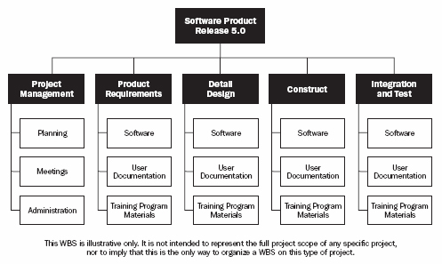
Fig. 5.1. A Guide to the Project Management Body of Knowledge (PMBOK Guide) 2000 Edition
Tools & Techniques for Scope Definition
Decomposition
- Involves subdividing the major project deliverables into smaller components.
- Decomposition involves the following major steps:
  - Identify the major deliverables of the project; The major deliverables should always be defined in terms of how the project will actually be organized.
  - Decide if adequate cost and duration estimates can be developed at this level of detail for each deliverable.
  - Identify constituent components of the deliverable; constituent components should be described in terms of tangible and verifiable results to facilitate performance measurement.
  - Verify the correctness of the decomposition:
    - Is each item clearly and completely defined?
    - Can each item be appropriately scheduled?
Outputs from Scope Definition
Work breakdown structure
- A WBS is a deliverable-oriented grouping of project components that organizes and defines the total scope of the project.
- It is often used to develop or confirm a common understanding of project scope.
- Each item in the WBS is assigned a unique identifier which provides a structure for a hierarchical summation of costs and resources.
- Work packages refers to the items at the lowest level of the WBS.
- Work component descriptions are often collected in a WBS dictionary.
- The WBS should not be confused with other kinds of “breakdown” structures used to present project information.
Scope statement updates
- Any modification of the content of the scope statement should be included in the updates.
- Appropriate stakeholders must be notified about the updates.
Scope Verification
- The process of obtaining formal acceptance of the project scope by the stakeholders.
- It requires reviewing deliverables and work results to ensure that all were completed correctly and satisfactorily.
- Scope verification differs from quality control (described in 8.3) in that it is primarily concerned with acceptance of the work results while quality control is primarily concerned with the correctness of the work results.
Some Tools & Techniques for Scope Verification
Inspection
- Inspection includes activities undertaken to determine whether results conform to requirements.
- These activities include:
  - Measuring
  - Examining
  - Testing
  - Also called reviews, audits, and walkthroughs.
Scope Change Control
- Must be thoroughly integrated with the other control processes.
- Controlling changes to project scope.
- It is also concerned with:
  - Influencing the factors that create scope changes to ensure that changes are agreed upon.
  - Determining that a scope change has occurred.
  - Managing the actual changes when and if they occur.
Tools & Techniques for Scope Change Control
Scope change control system
- Defines the procedures by which the project scope may be changed.
- It should be integrated with the integrated change control described in 4.3 and with any systems in place to control product scope.
Performance measurement
- Help to assess the magnitude of any variations that do occur.
- Determining what is causing the variance relative to the baseline and deciding if the variance requires corrective action.
- Performance measurement techniques will be described in 10.3.2 in details.
Additional planning
- Since sometimes projects run not exactly according to plan, prospective scope changes may require modifications to the WBS.

