The energy levels for an electron moving about a nucleus of charge +Ze are given by

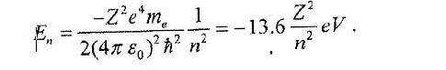
Calculate the first and third ionisation energies of 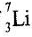, stating any assumptions you make for the effective Z value in each case.

