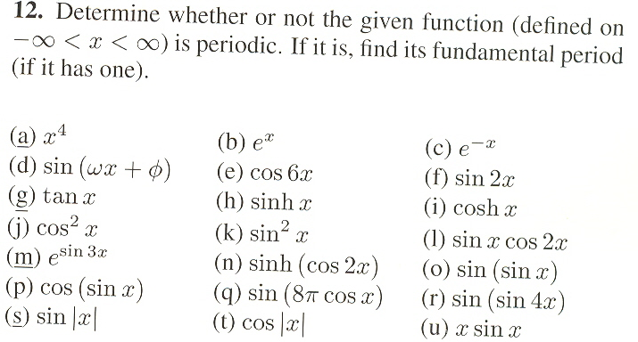

(Please solve for only (h) and (q). Thanks.)

The problems are from Even, Odd, and Periodic Functions.

