Bedrosian Incorporated has a line of credit from the Belmont National Bank that is due to be renewed on February 1. The bank has requested the company's current Income Statement and Comparative Statements of Financial Position which appear below.
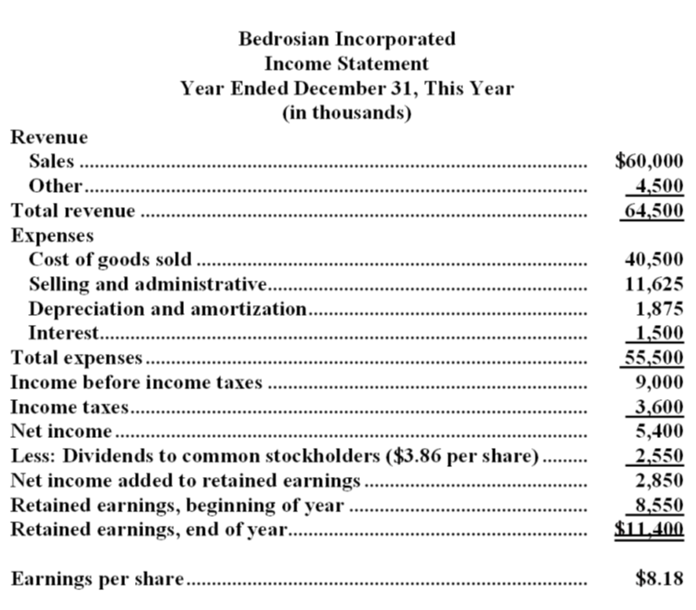
TAX RATE 40%

KEEP SCROOLING DOWN

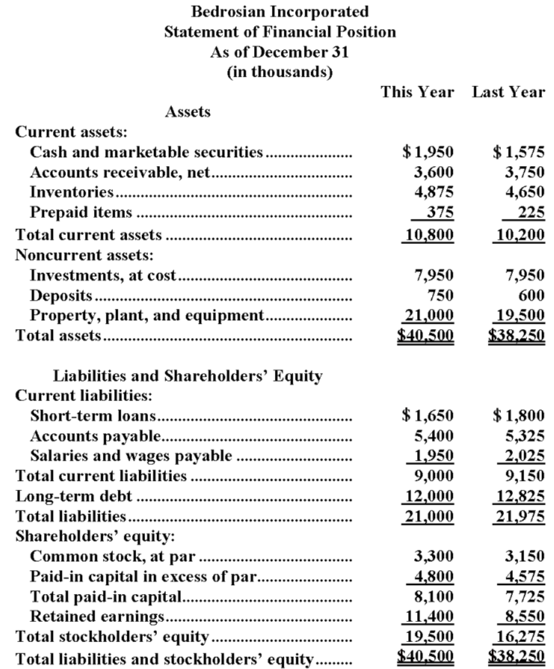
The bank has also requested that Bedrosian calculate a number of financial ratios. Bedrosian's financial ratios have not yet been calculated for this year, but the company's accounting staff has gathered the following industry averages for the ratios from various sources.
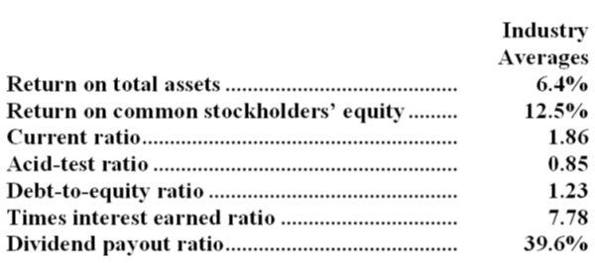
Required:

a. Calculate the following financial ratios for this year for Bedrosian Incorporated.
1. Return on total assets.
2. Return on common stockholders' equity.
3. Current ratio.
4. Acid-test ratio.
5. Debt-to-equity ratio.
6. Times interest earned.
7. Dividend payout ratio.
b. By comparing the ratios calculated in Requirement A with the industry ratios, evaluate Bedrosian's operations.

