Question 1: (1 points)
Evaluate the following integral
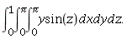

Question 2: (1 points)
Evaluate the following integral
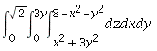
Question 3: (1 points)
Evaluate the following integral
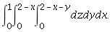
Question 4: (1 points)
Evaluate the following integral
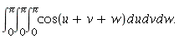
Question 5: (1 points)
Evaluate the following integral
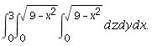

Question 6: (1 points)
Compute the area of the surface above the region
Question 7: (1 points)
Evaluate the following integral
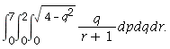
Question 8: (1 points)
Compute the area of the surface above the region

Question 9: (1 points)
Evaluate the following integral
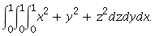
Question 10: (1 points)

For the integral below
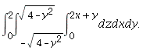
(a) |  |  | Rewrite the integral as an equivalent iterated integral in the order:  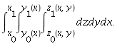  Fill-in boxes by correspondent values:
(b) |  |  | Evaluate the integral

