(NOTE: Hypothesis testing only for independent variable slopes (b1 and b2). Calculate the 95% Confidence intervals for b1 and b2.)
3 THE FUEL CONSUMPTION CASE
Use the output in (Fig 1a) to do (1) through (6) for each of β₀, β₁, and β₂ .

(Fig-1a) t Statistics and p-Values for Four Case Studies
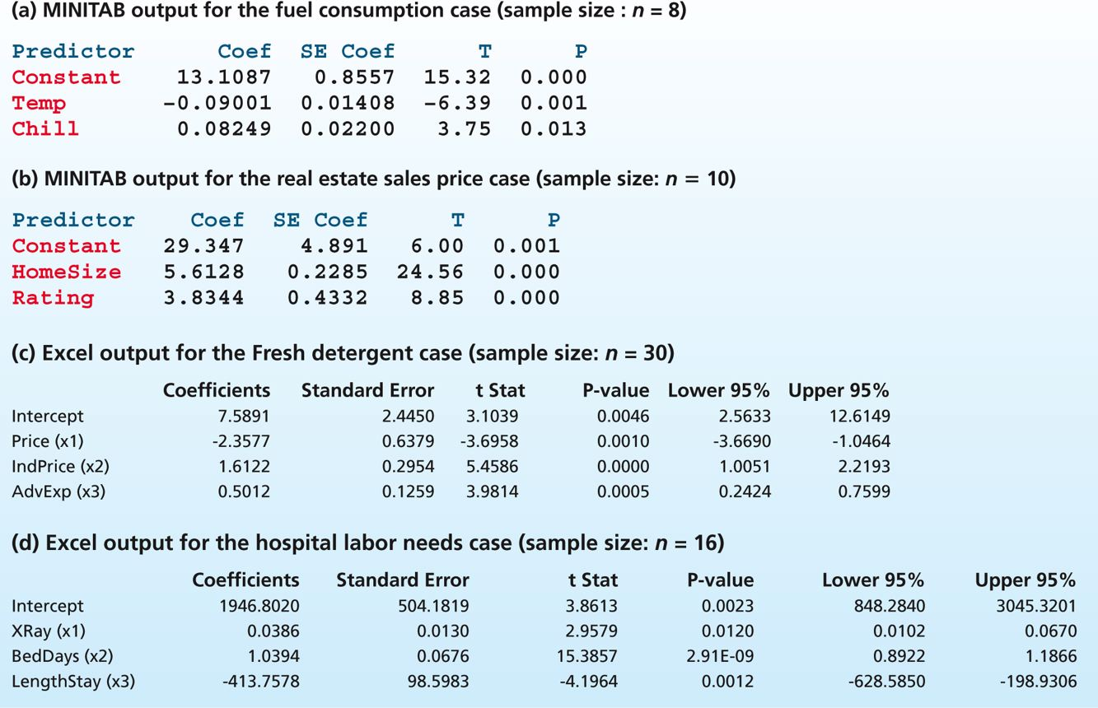

1 Find b_{j}, s_{bj}, and the t statistic for testing H₀ : β_{j} = 0 on the output and report their values. Show how t has been calculated by using b_{j} and s_{bj} .
2 Using the t statistic and appropriate critical values, test H₀ : β₁ = 0 versus H_{a} : ≠ 0 by setting a equal to .05. Which independent variables are significantly related to y in the model with a = .05?
3 Using the t statistic and appropriate critical values, test H₀ : β_{j} = 0 versus H_{a} : β_{j} ≠ 0 by setting α equal to .01. Which independent variables are significantly related to y in the model with α = .01?
4 Find the p-value for testing H₀ : β_{j} = 0 versus H_{a} : β_{j} ≠ 0 on the output. Using the p-value, determine whether we can reject H₀ by setting a equal to .10, .05, .01, and .001. What do you conclude about the significance of the independent variables in the model?
5 Calculate the 95 percent confidence interval for β_{j}. Discuss one practical application of this interval.
6 Calculate the 99 percent confidence interval for β_{j} .

