#1 THE HOSPITAL LABOR NEEDS CASE
(Table 1) presents data concerning the need for labor in 16 U.S. Navy hospitals. Here, y = monthly labor hours required; x₁ = monthly X-ray exposures; x₂ = monthly occupied bed days (a hospital has one occupied bed day if one bed is occupied for an entire day); and x₃ = average length of patients stay (in days). (Fig 1) gives the Excel output of a regression analysis of the data using the model

Table 1 Hospital Labor Needs Data
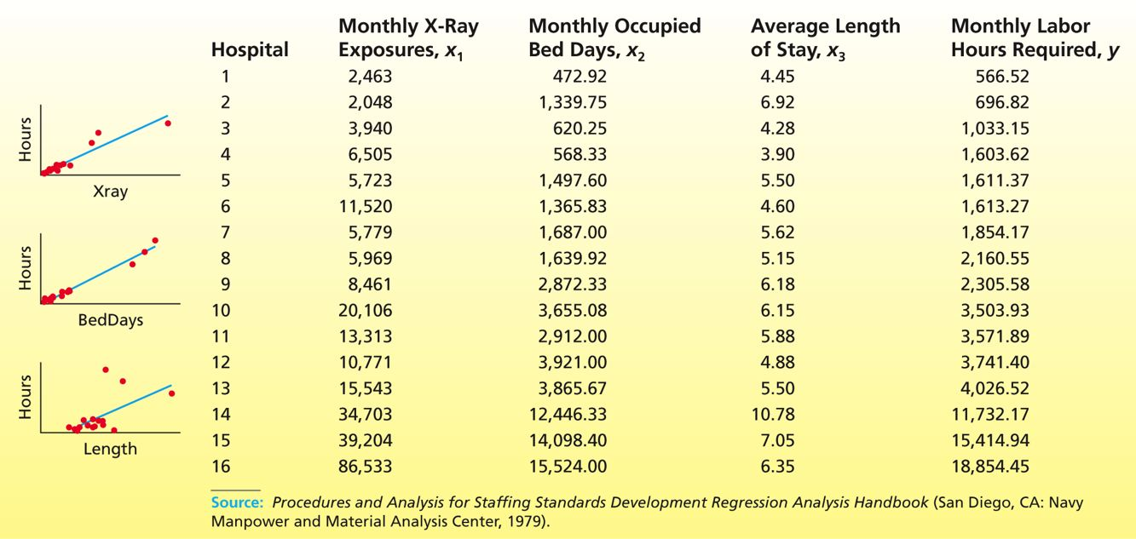

(Fig 1)Excel Output of a Regression Analysis of the Hospital Labor Needs Data Using the Model y = β₀ + β₁ x₁ + β₂ x₂ + β₃ x₃ + ε
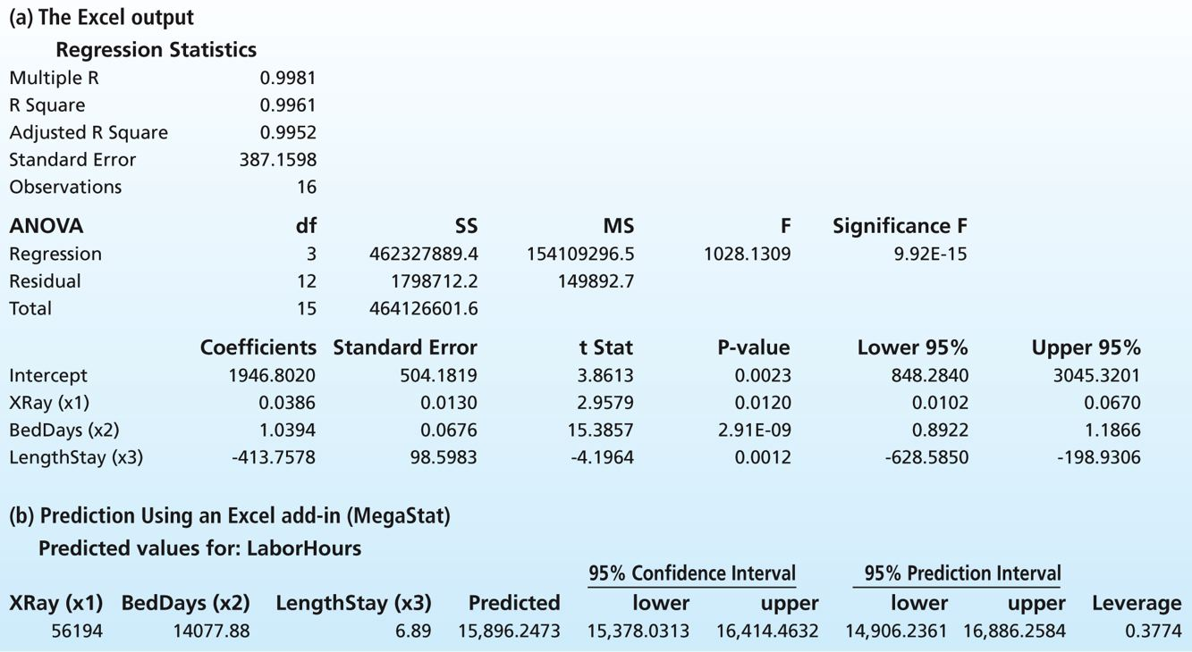
days (a hospital has one occupied bed day if one bed is occupied for an entire day); and x₃ = average length of patients’ stay (in days (Fig 1) gives the Excel output of a regression analysis of the data using the model
Note that the variables x₁, x₂, and x₃ are denoted as XRay, BedDays, and LengthStay on the output.
a. Find (on the output) and report the values of b₁, b₂, and b₃, the least squares point estimates of β₁, β₂, and β₃. Interpret b₁, b₂, and b₃ .
b. Consider a questionable hospital for which XRay = 56,194, BedDays = 14,077.88, and LengthStay = 6.89. A point prediction of the labor hours corresponding to this combination of values of the independent variables is given on the Excel add-in output.
Report this point prediction and show (within rounding) how it has been calculated.
c. If the actual number of labor hours used by the questionable hospital was y = 17,207.31, how does this y value compare with the point prediction?

