5. Leonard Matson completed these transactions during December of the current year:
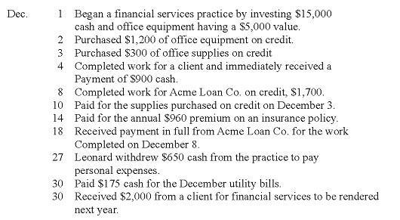
Prepare general journal entries to record these transactions.
9. A company allows its customers to use bank credit cards to charge purchases. When customers use the credit cards, the net amount is deposited in the company's checking account. The company also is charged a 2.5% service charge for these credit card sales. Assume that on April 13, the company sold $25,000 worth of merchandise to customers who used credit cards. Prepare the company's journal entry to record the credit card sales for April 13 assuming the company deposited the receipts that same day.
10. The following information is available for some of Coca-Cola's segments (all amounts are in millions):
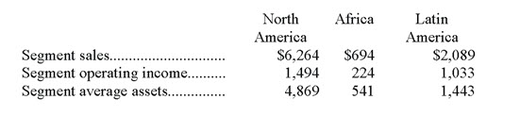
a. Determine the segment return on assets for each geographic segment.
b. Comment on the results. How do the segments compare with respect to profitability?

